Document  Name | Artistverse-SRS V.3.0 | Owner | NS , WS | Page | 11
Document  Type | Software Requirement  Specification | Release Date | 11/10/2024 | Print date | 11/10/2024

Chapter 2 Specification Requirement
2.1 Progress I
2.1.1 Use Case Scenario
2.1.1.1 Actor

Document  Name | Artistverse-SRS V.3.0 | Owner | NS , WS | Page | 12
Document  Type | Software Requirement  Specification | Release Date | 11/10/2024 | Print date | 11/10/2024

2.1.1.2 Use Case Diagram
Feature 1: Dynamic lyrics Composition
This use case diagram describes the part of this function work. In UC–01, songwriters
can access the compose lyrics and the lyrics provide an option to the songwriter to choose inUC-02,UC-03,UC-04 also when the songwriter completes the form that is selected by thesongwriter. System provides the save lyrics function to tell the songwriter that the song canbe saved to their device.
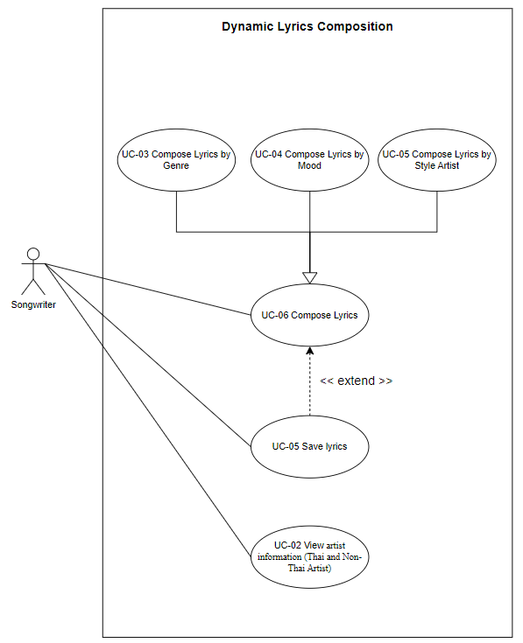
Document  Name | Artistverse-SRS V.3.0 | Owner | NS , WS | Page | 13
Document  Type | Software Requirement  Specification | Release Date | 11/10/2024 | Print date | 11/10/2024

Feature 2: Mood Detection Camera Integration
This use case diagram describes each part of this function. Firstly, Songwriters can
access the Capture facial expression and receive the recommended song by capturing thefacial expression and the system will display the song based on songwriter facial expression.In UC-07. after the Songwriter received the recommended song from the system. Songwriterscan also select songs to listen to on the Spotify platform.
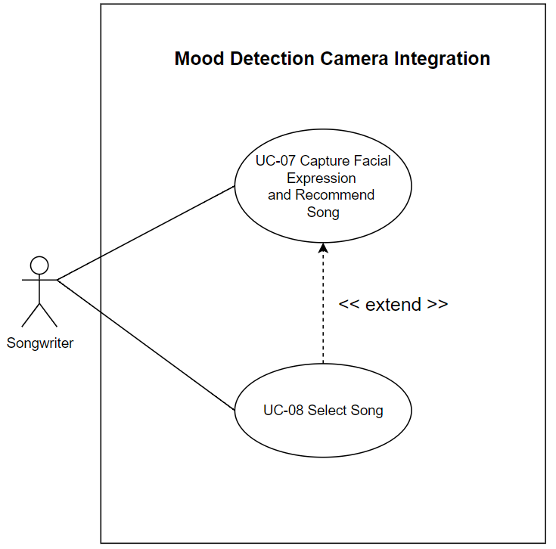
Document  Name | Artistverse-SRS V.3.0 | Owner | NS , WS | Page | 14
Document  Type | Software Requirement  Specification | Release Date | 11/10/2024 | Print date | 11/10/2024

2.2 Progress II
2.2.1 Use Case Scenario
2.2.1.1 Actor

Document  Name | Artistverse-SRS V.3.0 | Owner | NS , WS | Page | 15
Document  Type | Software Requirement  Specification | Release Date | 11/10/2024 | Print date | 11/10/2024

2.2.1.2 Use Case Diagram
Feature 3: Chord Progression
This use case allows the songwriter to access and view detailed chord progression
information. It represents the main entry point for interacting with the chord progressionfeatures. This use case extends UC-10, meaning that when the songwriter accesses chordprogression information, they can also choose to view and interact with the chord progressionchart.
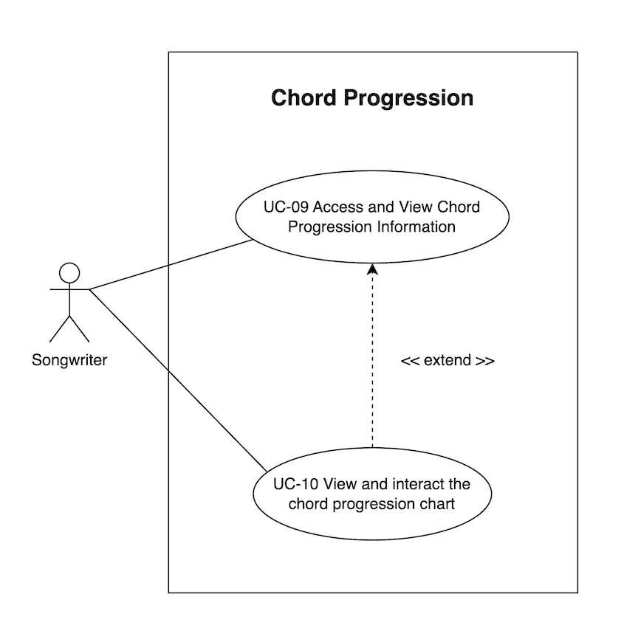
Document  Name | Artistverse-SRS V.3.0 | Owner | NS , WS | Page | 16
Document  Type | Software Requirement  Specification | Release Date | 11/10/2024 | Print date | 11/10/2024

Feature 4: AI Lyrics Analysis
This use case allows the songwriter to input lyrics and receive a musical analysis from
an AI Analysis page. The songwriter can view how the lyrics align with musical elementssuch as melody, rhythm, and harmony. This use case extends UC-12, indicating that afterinputting lyrics and viewing the analysis, the songwriter can save the lyrics after they havebeen analyzed by the AI system. It extends UC-11, meaning that saving the lyrics is anoptional extension after viewing the musical analysis.
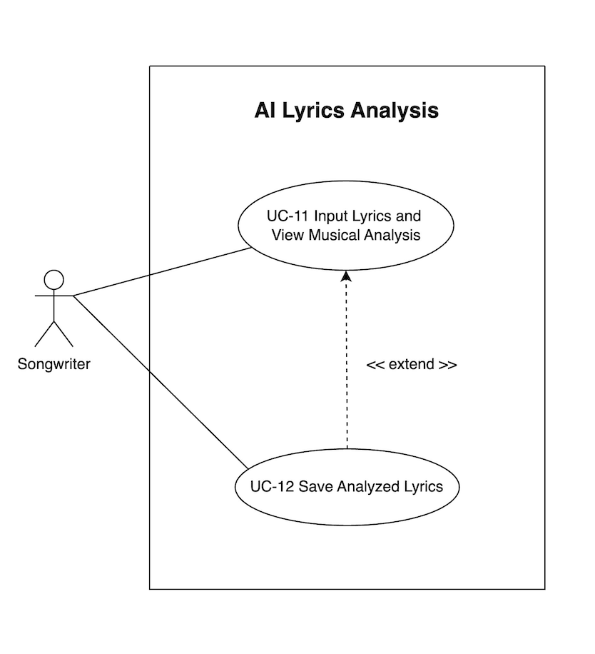
Document  Name | Artistverse-SRS V.3.0 | Owner | NS , WS | Page | 17
Document  Type | Software Requirement  Specification | Release Date | 11/10/2024 | Print date | 11/10/2024

2.1.2 User Requirement Specification
Feature#1: Dynamic Lyric Composition
URS-01: The songwriter can access lyric-generation options. (Genre, Mood, andStyle Artist)
URS-02:The songwriter can view artist information. (Thai and Non-Thai Artists)URS-03: The songwriter can compose lyrics by Genre. (pop rock, country R&B,hip-hop, folk, indie, electronic jazz, blues reggae, classical, alternative, gospel, andpunk)
URS-04: The songwriter can compose lyrics by Mood. (sad, angry, surprised, fearful,and happy)
URS-05: The songwriter can compose lyrics from Style Artist. (Taylor Swift, BillieEilish, Ed Sheeran, Justin Bieber, The Weeknd, Maroon 5, Olivia Rodrigo, The 1975,Joji, Keshi, Potato, Palmy, Big Ass, Lula, Lipta, Scrubb, Stamp, Getsunova, and DaEndorphine.)
URS-06:The Songwriter can save lyrics after composing lyrics.
Feature#2 Mood Detection Camera Integration
URS-07: The songwriter can receive recommended songs from Spotify according tothe mood from facial expressions mood
URS-08: The songwriter can listen to songs recommended in playlists on Spotify.
Feature #3: Chord Progression
URS:09: The songwriter can access the "Chord Progression" page to viewinformation, selecting from the navigation options provided in SRS-02.
URS-10: The songwriter can view the chord progression chart after accessing the"Chord Progression" page.
Feature #4: AI Lyrics Analysis
URS:11: The songwriter can input lyrics into a text field and view a detailed musicalanalysis based on the lyrics input, selecting from the navigation options provided inSRS-02.
URS:12: The songwriter can save information as a .txt file on their local computerafter analyzing the input lyrics.
Document  Name | Artistverse-SRS V.3.0 | Owner | NS , WS | Page | 18
Document  Type | Software Requirement  Specification | Release Date | 11/10/2024 | Print date | 11/10/2024

2.1.3 Use Case Description and Activity Diagram
2.1.3.1 UCD-01
URS-01: The songwriter can access lyric-generation options. (Genre, Mood, and Style Artist)
●  ● | SRS-01: The system shall display the "navbar-toggler-icon" button on every page'stop right bar.  ●  SRS-02: The system shall display a drop-down menu bar with buttons for
 | "Homepage", | "Lyric | Generator", | "Mood | Camera", | "Chord | Progression" | and
"AI-Analysis." Clicking on each button will take the user to the respective page.
●  ● | SRS-03: After the "Lyric Generator" button on the navbar is clicked, The system shalldisplay a lyrics generator page [UI-03] with the "let's generate" button to startgenerating lyrics.  SRS-04: After the "let's generate" button on UI-03 is clicked, The system shall displayoptions for composing lyrics, including "Lyric Generator by Genre", "Lyric Generatorby Mood" and "Lyric Generator by Style Artist" after the "let's generate" button isclicked.  ●  ●

Use Case ID | UC-01
Use Case  name | Access Lyric Generation Options
Created By | NS, WS | Last Update By |  | NS, WS
Data create | 10/05/2024 | Last revision |  | 29/05/2024
Actors | Songwriter
Description | This use case describes the process by which a songwriter navigatesto the lyrics generator page and accesses various options for  composing lyrics, such as by genre, mood, and style artist.
Trigger | Songwriter click the “navbar-toggler-icon” button in the top right barof the website and select Lyric Generator.
Preconditions | "navbar-toggler-icon" button on every page present on the webpage.[UI-02]
Use Case Input Specification
Input | Type | Constraint |  | Example
- | - | - |  | -
Post  conditions | The songwriter has access to the Lyric Generator by Genre page[UI-04].
Normal flows | User |  | System

Document  Name | Artistverse-SRS V.3.0 | Owner | NS , WS | Page | 19
Document  Type | Software Requirement  Specification | Release Date | 11/10/2024 | Print date | 11/10/2024

 | 2. Click on the  "navbar-toggler-icon"  button.  4. Select "Lyric Generator"from the dropdown menu.  6. Click on the button  “Let’s Generate” | 1. Displays the "navbar-toggler-icon"button in every page's top right bar.  3. displays a dropdown navbar.  5. Displays the lyrics generator page.[UI-03]  7. Display a lyrics generator page andpresent options for composing lyrics:"Lyric Generator by Genre", "LyricGenerator by Mood", and "Lyric  Generator by Style Artist". [UI-04]
Alternate  Flow | -
Exception  Flow | -
Assumption | The songwriter has an internet connection

Document  Name | Artistverse-SRS V.3.0 | Owner | NS , WS | Page | 20
Document  Type | Software Requirement  Specification | Release Date | 11/10/2024 | Print date | 11/10/2024

AD-01: Access Lyric Generation Options
The activity diagram shows the steps to using the lyric generator, starting with
accessing the drop-down menu on the website and selecting the lyric generator page, whichgives users the option to choose how to generate lyrics based on Genre, Mood, or StyleArtist, to make it easier for songwriters to create lyrics.
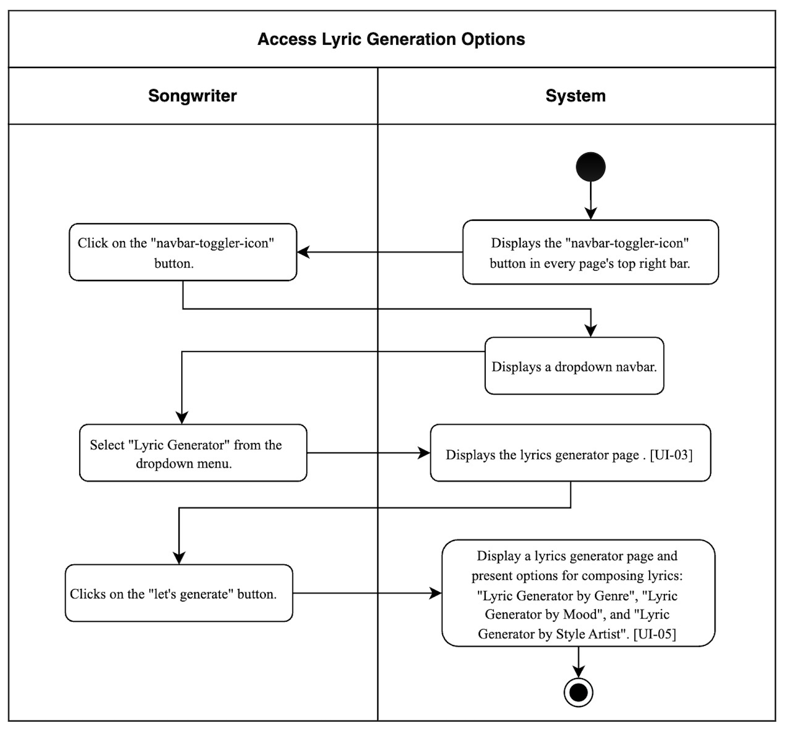
Document  Name | Artistverse-SRS V.3.0 | Owner | NS , WS | Page | 21
Document  Type | Software Requirement  Specification | Release Date | 11/10/2024 | Print date | 11/10/2024

2.1.3.2 UCD-02
URS-02: The songwriter can view artist information. (Thai and Non-Thai Artists)
●  ●  ●  ● | SRS-05: After the "Show Thai Artists" button on UI-03 is clicked, the system shalldisplay the picture and name of the Thai artist along with the "Show Non-ThaiArtists" button.  SRS-06: After the "Show Non-Thai Artists" button on UI-03-1 is clicked, the systemshall display the picture and name of the non-Thai artist along with the "Show ThaiArtists" button.  SRS-07: On the UI-03, the system shall provide a scroll bar to enable the songwriterto navigate through additional non-Thai artist information beyond the initial viewablearea.  SRS-08: On the UI-03-1, the system shall provide a scroll bar to enable the songwriterto navigate through additional Thai artist information beyond the initial viewable area.  ●  ●  ●  ●

Use Case ID | UC-02
Use Case  name | View Artist Information
Created By | NS, WS | Last Update By |  | NS, WS
Data create | 10/05/2024 | Last revision |  | 29/05/2024
Actors | Songwriter
Description | This use case describes the process by which a songwriter views andswitches between Thai and non-Thai artists on the lyric generatorpage.
Trigger | Songwriter clicks the "Show Thai Artists" button [UI-03] or "ShowNon-Thai Artists" button [UI-03-1].
Preconditions | The songwriter is on the lyrics generator page with artist informationdisplayed. [UI-03]
Use Case Input Specification
Input | Type | Constraint |  | Example
- | - | - |  | -
Post  conditions | The system displays the selected artist information (Thai or  non-Thai) with a button to switch back.
Normal flows | User |  | System

Document  Name | Artistverse-SRS V.3.0 | Owner | NS , WS | Page | 22
Document  Type | Software Requirement  Specification | Release Date | 11/10/2024 | Print date | 11/10/2024

 | 1. Click the "Show Thai  Artists" button.  4. Use the scroll bar to seeadditional Thai artist  information.  5. Click the "Show  Non-Thai Artists" button.  6. Use the scroll bar to seeadditional non-Thai artist  information. | 2. Displays Thai artist information  along with the "Show Non-Thai  Artists" button. [UI-03-1]  3. Displays a scroll bar to navigate  through additional Thai artist  information.  5. Displays the picture and name ofthe non-Thai artist along with the  "Show Thai Artists" button. [UI-03]  6. Displays a scroll bar to navigate  through additional non-Thai artist  information.
Alternate  Flow | -
Exception  Flow | -
Assumption | The songwriter has an internet connection

Document  Name | Artistverse-SRS V.3.0 | Owner | NS , WS | Page | 23
Document  Type | Software Requirement  Specification | Release Date | 11/10/2024 | Print date | 11/10/2024

AD-02: View Artist Information
The activity diagram shows the steps to view and switch between Thai and non-Thai
artist information on the lyric generator page.
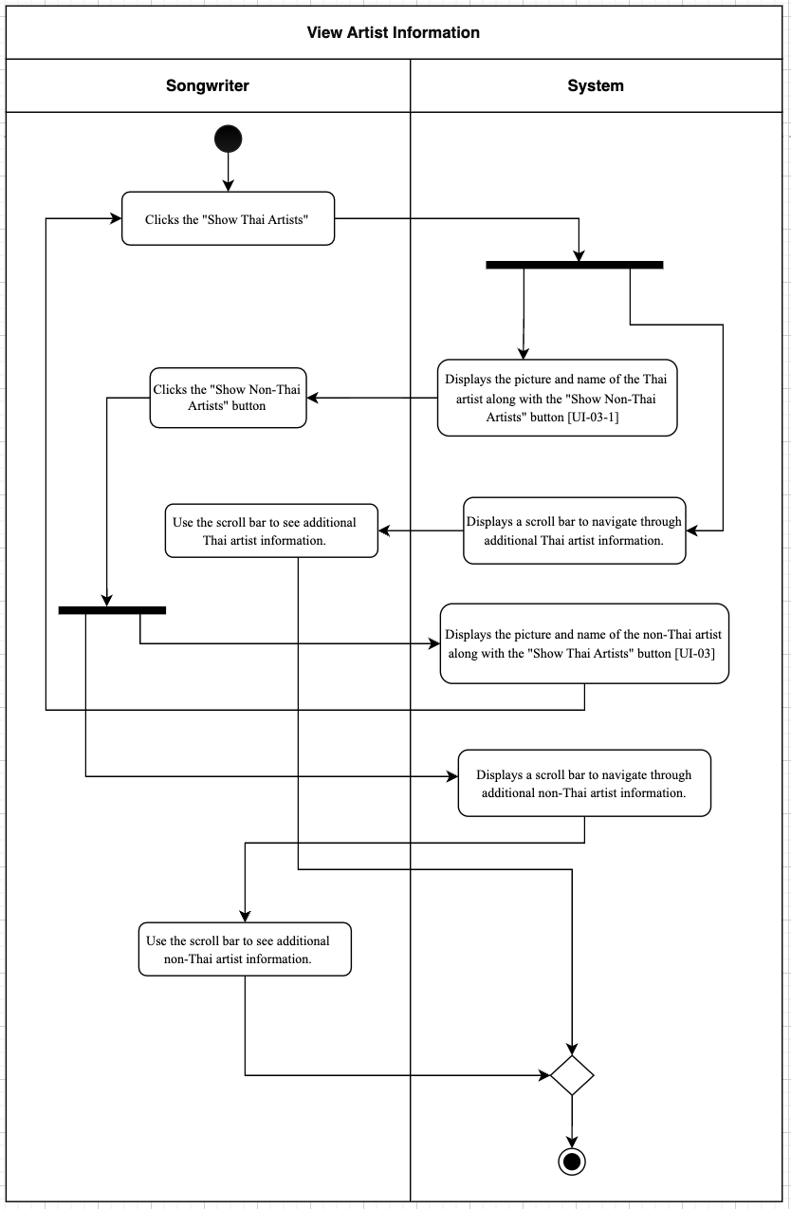
Document  Name | Artistverse-SRS V.3.0 | Owner | NS , WS | Page | 24
Document  Type | Software Requirement  Specification | Release Date | 11/10/2024 | Print date | 11/10/2024

2.1.3.3 UCD-03
URS-03: The songwriter can compose lyrics by Genre. (pop rock, country R&B, hip-hop,folk, indie, electronic jazz, blues reggae, classical, alternative, gospel, and punk).
●  ●  ●  ● | SRS-09: The system shall display a lyrics generator page with options for "LyricGenerator by Genre," "Lyric Generator by Mood," and "Lyric Generator by StyleArtist."  SRS-10: The system shall provide forms to fill in the genre information, includinglyric topic, genre, and language.  SRS-11: The system shall generate lyrics based on the input provided by the user.  ●  ●  ●  SRS-12: If the songwriter attempts to proceed without completing all required genreinformation input fields, the system shall display an error message indicating themissing fields. The error message consists of "Please input a lyric topic.", "Please
 | select genre.","Please select a language. [UI-04-1]
●  ●  ● | SRS-13: If there is no internet connection, the system shall display an error message"Unable to compose lyrics." [UI-04-4]  SRS-14: The system shall allow the songwriter to generate new lyrics by filling in thegenre information form again on the Lyric Generator by Genre page. [UI-04-2]  SRS-15: The system shall display the created lyrics to the songwriter based on thesongwriter selected.  ●  ●  ●

Use Case ID | UC-03
Use Case  name | Compose Lyrics by Genre
Created By | NS, WS | Last Update By | NS, WS
Data create | 15/05/2024 | Last revision | 29/05/2024
Actors | Songwriter
Description | This use case describes generating lyrics based on a selected genre.
Trigger | The songwriter selects the "Lyric Generator by Genre" option on thelyrics generator page. [UI-04]
Preconditions | UC-01
Use Case Input Specification
Input | Type | Constraint | Example
Lyric topic | String | Required | “My love”
Genre | Dropdown  selection | Select One Genre: pop,  rock, country, R&B, hiphop, folk, indie,  electronic jazz, blues, | “pop”

Document  Name | Artistverse-SRS V.3.0 | Owner | NS , WS | Page | 25
Document  Type | Software Requirement  Specification | Release Date | 11/10/2024 | Print date | 11/10/2024

reggae, classical,
alternative, gospel,
punk
Language | Dropdown selection | Select One Language:  English, Thai, Japanese,Chinese |  | “English”
Post  conditions | The generated lyrics are displayed to the songwriter.
Normal flows | User |  | System
 | 2. Select "Lyric Generatorby Genre". [UI-04]  4. The songwriter fills in  information in the form  [UI-04-2]  5. Click on the "Generate"button to generate lyrics.  [UI-04-2] |  | 1. Display a lyrics generator page andpresent options for composing lyrics:"Lyric Generator by Genre", "LyricGenerator by Mood", and "Lyric  Generator by Style Artist". [UI-04]  3. Provide forms to fill in the genreinformation, including the lyric topic,genre, and language. [UI-04]  6. Check if all required input fields arecompleted.  (6A: If the songwriter attempts to  proceed without completing all requiredinput fields.)  7. The system displays the created  lyrics to the songwriter based on the  songwriter selected. [UI-04-3]  (7A: Unable to displays the lyrics  causing by no internet connection )  (7B: If the songwriter wants to generatenew lyrics by fill information in the  form.)

Document  Name | Artistverse-SRS V.3.0 | Owner | NS , WS | Page | 26
Document  Type | Software Requirement  Specification | Release Date | 11/10/2024 | Print date | 11/10/2024

Alternate  Flow | [6A: If the songwriter attempts to proceed without completing allrequired input fields.]  1. The system will display an error message indicating the missing  fields. The error message consists of "Please input a lyrictopic.", "Please select genre.","Please select a language.[UI-04-1]  2. Go to normal flow 4  [7B: If the songwriter wants to generate new lyrics by fill  information in the form.]  1. Go to normal flow 4.
Exception  Flow | [7A: Unable to displays the lyrics causing by no internet  connection]  1. The system will display “Unable to compose lyrics” [UI-04-4]2. The use case ends.
Assumption | The songwriter has an internet connection

Document  Name | Artistverse-SRS V.3.0 | Owner | NS , WS | Page | 27
Document  Type | Software Requirement  Specification | Release Date | 11/10/2024 | Print date | 11/10/2024

AD-03: Compose Lyrics by Genre
Activity Diagram for Compose Lyrics by Genre, which explains the steps. Between a
songwriter and a system for creating Genre lyrics.
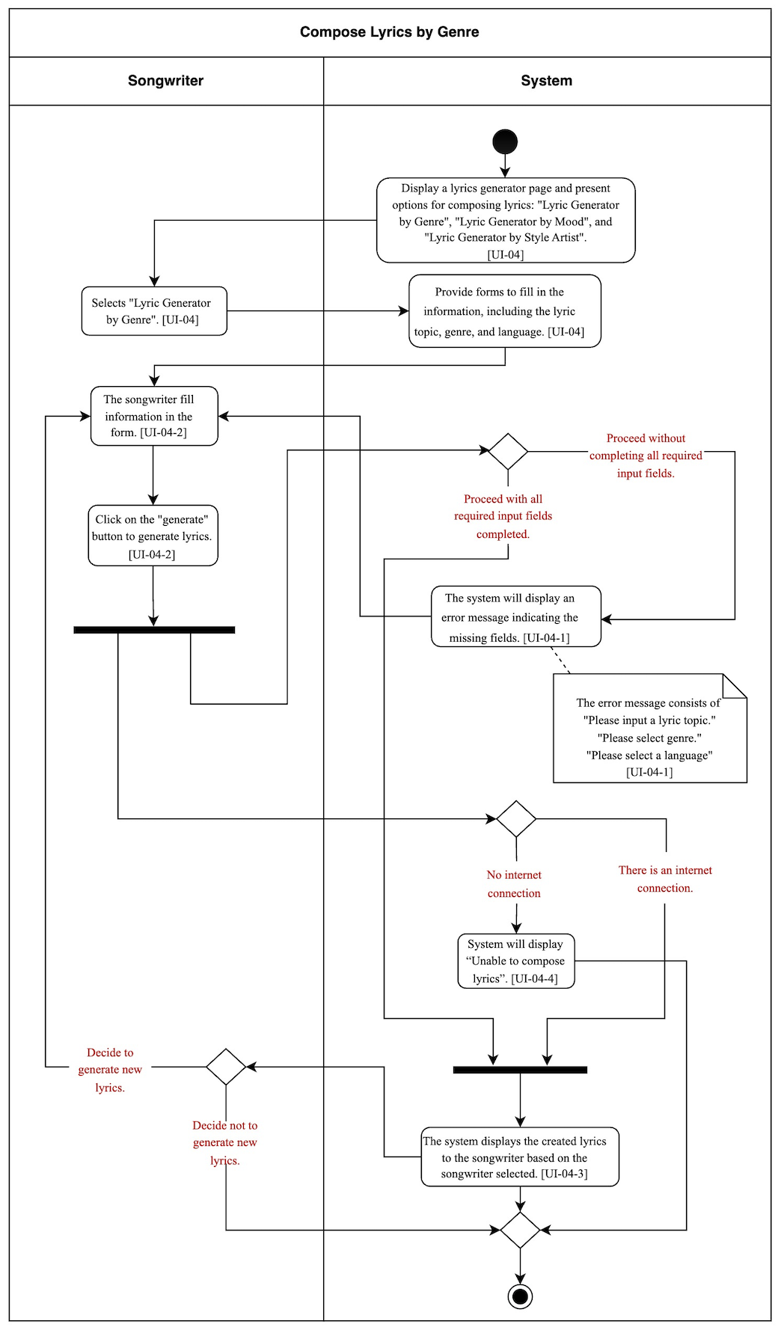
Document  Name | Artistverse-SRS V.3.0 | Owner | NS , WS | Page | 28
Document  Type | Software Requirement  Specification | Release Date | 11/10/2024 | Print date | 11/10/2024

2.1.3.4 UCD-04: Compose Lyrics by Mood
URS-04: The songwriter can compose lyrics by Mood. (sad, angry, surprised, fearful, andhappy)
●  ●  ●  ● | SRS-16: The system shall display a lyrics generator page with options for "LyricGenerator by Genre," "Lyric Generator by Mood," and "Lyric Generator by StyleArtist."  SRS-17: The system shall provide forms to fill in the mood information, includinglyric topic, mood, and language.  SRS-18: The system shall generate lyrics based on the input provided by the user.  ●  ●  ●  SRS-19: If the songwriter attempts to proceed without completing all required moodinformation input fields, the system shall display an error message indicating themissing fields. The error message consists of "Please input a lyric topic.", "Please
 | select mood.","Please select a language.
●  ●  ● | SRS-20: If there is no internet connection, the system shall display an error message"Unable to compose lyrics." [UI-05-3]  SRS-21: The system shall allow the songwriter to generate new lyrics by filling in themood information form again on the Lyric Generator by Mood page. [UI-05-1]  SRS-22: The system shall display the created lyrics to the songwriter based on thesongwriter selected.  ●  ●  ●

Use Case ID | UC-04
Use Case  name | Compose Lyrics by Mood
Created By | NS, WS | Last Update By | NS, WS
Data create | 15/05/2024 | Last revision | 29/05/2024
Actors | Songwriter
Description | This use case describes the process of generating lyrics based on aselected mood.
Trigger | The songwriter selects the "Lyric Generator by Mood" option on thelyrics generator page. [UI-05]
Preconditions | UC-01
Use Case Input Specification
Input | Type | Constraint | Example
Lyric topic | String | Required | “My love”
Mood | Dropdown  selection | Select One Mood:  happy, sad, romantic,  inspirational, energetic, | “Sad”

Document  Name | Artistverse-SRS V.3.0 | Owner | NS , WS | Page | 29
Document  Type | Software Requirement  Specification | Release Date | 11/10/2024 | Print date | 11/10/2024

chill, hopeful,
reflective, mysterious,
dramatic, nostalgic,
playful, confident,
dreamy, empowering
Language | Dropdown selection | Select One Language:  English, Thai, Japanese,Chinese |  | “English”
Post  conditions | The generated lyrics are displayed to the songwriter.
Normal flows | User |  | System
 | 2. Select "Lyric Generatorby Mood". [UI-05]  4. The songwriter fills in  information in the form.  [UI-05-1]  5. Click on the "Generate"button to generate lyrics.  [UI-05-1] |  | 1. Display a lyrics generator page andpresent options for composing lyrics:"Lyric Generator by Genre", "LyricGenerator by Mood", and "Lyric  Generator by Style Artist". [UI-04]  3. Provide forms to fill in the moodinformation, including the lyric topic,mood, and language. [UI-05]  6. Check if all required input fields arecompleted.  (6A: If the songwriter attempts to  proceed without completing all requiredinput fields.)  7. The system displays the created  lyrics to the songwriter based on the  songwriter selected. [UI-05-4]  (7A: Unable to displays the lyrics  causing by no internet connection )

Document  Name | Artistverse-SRS V.3.0 | Owner | NS , WS | Page | 30
Document  Type | Software Requirement  Specification | Release Date | 11/10/2024 | Print date | 11/10/2024

(7B: If the songwriter wants to generatenew lyrics by fill information in the
form.)
Alternate  Flow | [6A: If the songwriter attempts to proceed without completing allrequired input fields.]  1. The system will display an error message indicating the missing  fields. The error message consists of "Please input a lyrictopic.", "Please select mood.","Please select a language.[UI-05-2]  2. Go to normal flow 4  [7B: If the songwriter wants to generate new lyrics by fill  information in the form.]  1. Go to normal flow 4.
Exception  Flow | [7A: Unable to displays the lyrics causing by no internet  connection]  1. System will display “Unable to compose lyrics” [UI-05-3]2. The use case ends.
Assumption | The songwriter has an internet connection

Document  Name | Artistverse-SRS V.3.0 | Owner | NS , WS | Page | 31
Document  Type | Software Requirement  Specification | Release Date | 11/10/2024 | Print date | 11/10/2024

AD-04: Compose Lyrics by Mood
Activity Diagram for Compose Lyrics by Mood, which explains the steps. Between a
songwriter and a system for creating emotional lyrics.
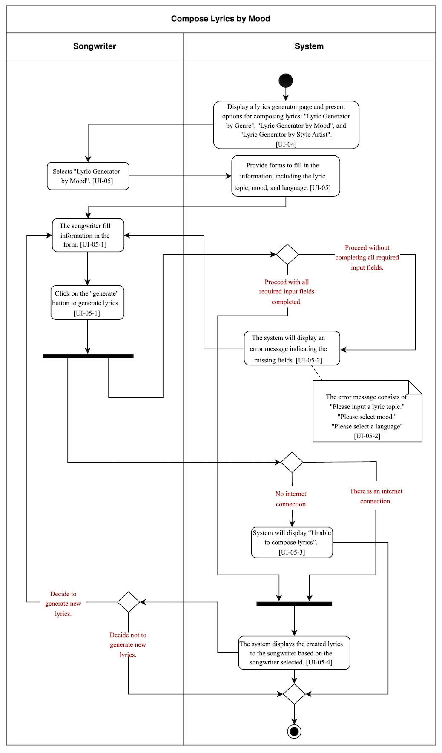
Document  Name | Artistverse-SRS V.3.0 | Owner | NS , WS | Page | 32
Document  Type | Software Requirement  Specification | Release Date | 11/10/2024 | Print date | 11/10/2024

2.1.3.5 UCD-05 : Compose Lyrics by Style Artist
URS-05: The songwriter can compose lyrics from Style Artist. (Taylor Swift, Billie Eilish, EdSheeran, Justin Bieber, The Weeknd, Maroon 5, Olivia Rodrigo, The 1975, Joji, Keshi,Potato, Palmy, Big Ass, Lula, Lipta, Scrubb, Stamp, Getsunova, and Da Endorphine.)
●  ●  ●  ● | SRS-23: The system shall display a lyrics generator page with options for "LyricGenerator by Genre," "Lyric Generator by Mood," and "Lyric Generator by StyleArtist."  SRS-24: The system shall provide forms to fill in the style artist information,including lyric topic, artist, and language.  SRS-25: The system shall generate lyrics based on the input provided by the user.  ●  SRS-26: If the songwriter attempts to proceed without completing all required genremissing fields. The error message consists of "Please input a lyric topic.", "Please  information input fields, the system shall display an error message indicating the
 | select artist.","Please select a language. [UI-06-1]
●  ●  ● | SRS-27: If there is no internet connection, the system shall display an error message  "Unable to compose lyrics." [UI-06-3]  SRS-28: The system shall allow the songwriter to generate new lyrics by filling in thegenre information form again on the Lyric Generator by Genre page. [UI-06-2]  SRS-29: The system shall display the created lyrics to the songwriter based on the  songwriter selected.

Use Case ID | UC-05
Use Case  name | Compose Lyrics by Style Artist
Created By | NS, WS | Last Update By | NS, WS
Data create | 15/05/2024 | Last revision | 29/05/2024
Actors | Songwriter
Description | This use case describes the process of generating lyrics based on aselected style artist.
Trigger | The songwriter selects the "Lyric Generator by Style Artist" optionon the lyrics generator page. [UI-06]
Preconditions | UC-01
Use Case Input Specification
Input | Type | Constraint | Example
Lyric topic | String | Required | “Sad story”

Document  Name | Artistverse-SRS V.3.0 | Owner | NS , WS | Page | 33
Document  Type | Software Requirement  Specification | Release Date | 11/10/2024 | Print date | 11/10/2024

Artist | Dropdown  selection | Select One Artist:  Taylor Swift, Billie  Eilish, Ed Sheeran,  Justin Bieber, The  Weeknd, Maroon 5,  Olivia Rodrigo, The  1975, Joji, Keshi,  Potato, Palmy, Big Ass,Lula, Lipta, Scrubb,  Stamp, Getsunova, Da  Endorphine |  | “Taylor Swift”
Language | Dropdown selection | Select One Language:  English, Thai, Japanese,Chinese |  | “English”
Post  conditions | The generated lyrics are displayed to the songwriter.
Normal flows | User |  | System

Document  Name | Artistverse-SRS V.3.0 | Owner | NS , WS | Page | 34
Document  Type | Software Requirement  Specification | Release Date | 11/10/2024 | Print date | 11/10/2024

 | 2. Select "Lyric Generatorby Style Artist". [UI-06]  4. The songwriter fills in  information in the form  [UI-06-2]  5. Click on the "Generate"button to generate lyrics.  [UI-06-2] | 1. Display a lyrics generator page andpresent options for composing lyrics:"Lyric Generator by Genre", "LyricGenerator by Mood", and "Lyric  Generator by Style Artist". [UI-04]  3. Provide forms to fill in the style  artist information, including the lyrictopic, artist, and language. [UI-06]  6. Check if all required input fields arecompleted.  (6A: If the songwriter attempts to  proceed without completing all requiredinput fields.)  7. The system displays the created  lyrics to the songwriter based on the  songwriter selected. [UI-06-4]  (7A: Unable to displays the lyrics  causing by no internet connection )  (7B: If the songwriter wants to generatenew lyrics by fill information in the  form.)
Alternate  Flow | [6A: If the songwriter attempts to proceed without completing allrequired input fields.]  1. The system will display an error message indicating the missing  fields. The error message consists of "Please input a lyrictopic.", "Please select artist.","Please select a language.[UI-06-1]  2. Go to normal flow 4

Document  Name | Artistverse-SRS V.3.0 | Owner | NS , WS | Page | 35
Document  Type | Software Requirement  Specification | Release Date | 11/10/2024 | Print date | 11/10/2024

[7B: If the songwriter wants to generate new lyrics by fill
information in the form.]
1. Go to normal flow 4.
Exception  Flow | [7A: Unable to displays the lyrics causing by no internet  connection]  1. System will display “Unable to compose lyrics” [UI-06-3]2. The use case ends.
Assumption | The songwriter has an internet connection

Document  Name | Artistverse-SRS V.3.0 | Owner | NS , WS | Page | 36
Document  Type | Software Requirement  Specification | Release Date | 11/10/2024 | Print date | 11/10/2024

AD-05: Compose Lyrics by Style Artist
This activity diagram shows how to compose lyrics using a style artist feature in a
lyrics generation system. It describes the steps between the songwriter and the system tocreate lyrics in the style of a chosen artist.
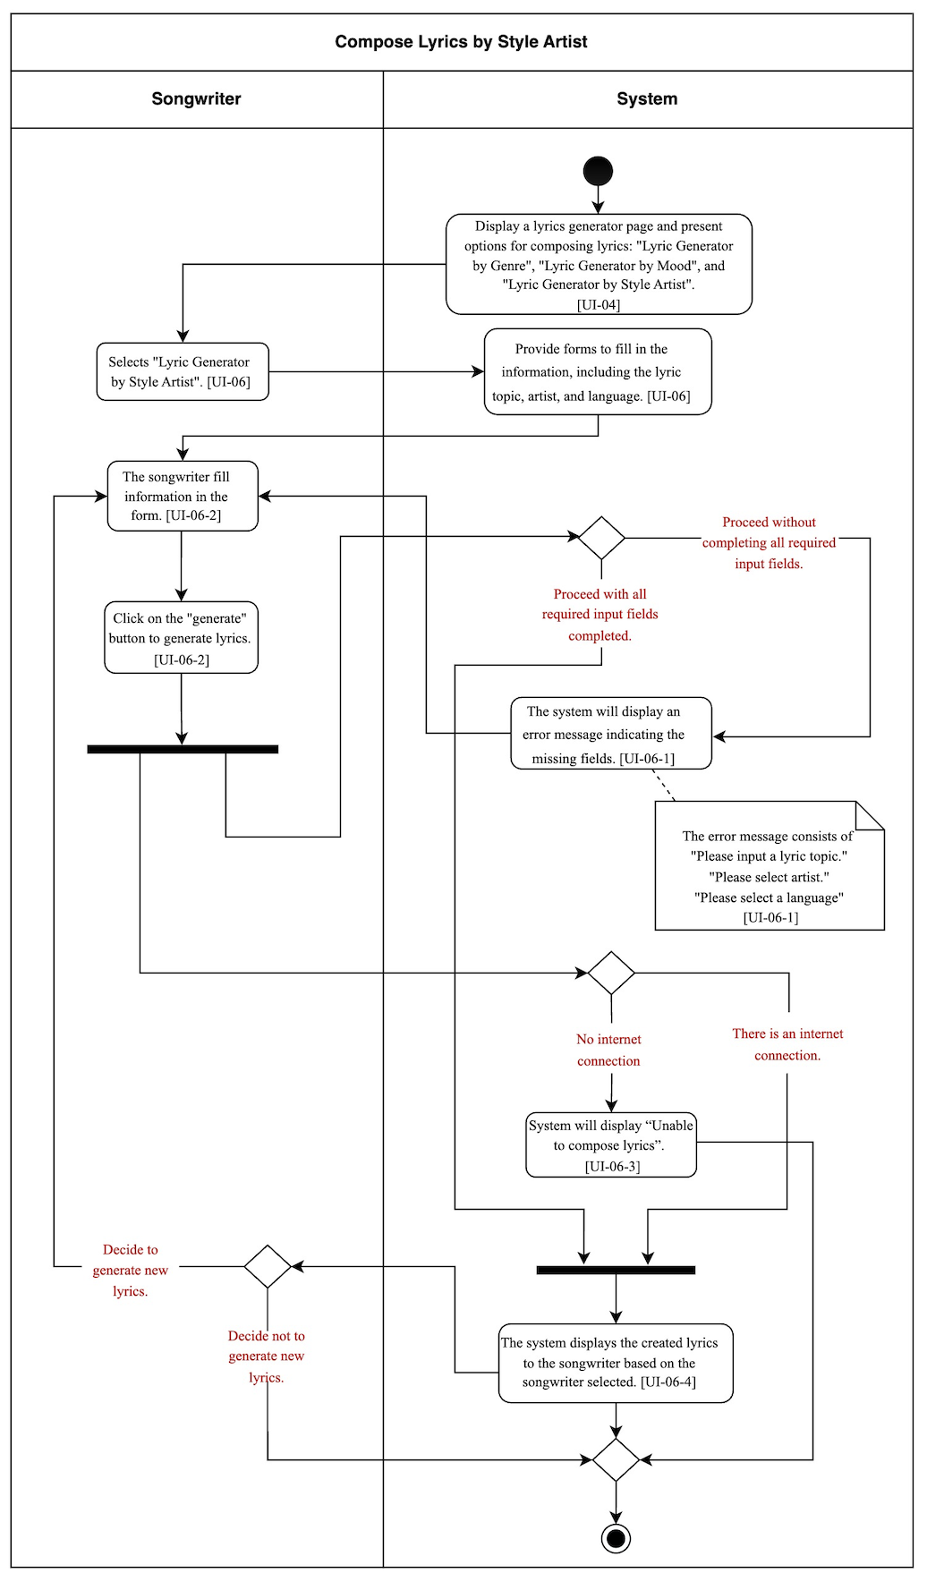
Document  Name | Artistverse-SRS V.3.0 | Owner | NS , WS | Page | 37
Document  Type | Software Requirement  Specification | Release Date | 11/10/2024 | Print date | 11/10/2024

2.1.3.6 UCD-06 : Save lyrics
URS-06: The songwriter can save lyrics after composing lyrics.
●  ●  ● | SRS-30: The system shall provide a "Save" button that allows the songwriter to savethe created lyrics. [UI-04-3, UI-05-4, UI-06-4]  SRS-31: the system shall save the lyrics to the songwriter's local computer in a .txtfile format. [UI-07]  SRS-32: If there is no internet connection, the system shall display an error message"Unable to save lyrics." [UI-07-1]  ●  ●  ●

Use Case  ID | UC-06
Use Case  name | Save lyrics
Created  By | NS, WS | Last Update By |  | NS, WS
Data  create | 11/05/2024 | Last revision |  | 29/05/2024
Actors | Songwriter
Descriptio  n | This use case describes the process for saving generated lyrics to thesongwriter's local computer.
Trigger | The songwriter clicks the "Save" button after the lyrics have been  generated and displayed in the UC-02, UC-03, or UC-04.
Preconditi  ons | UC-02, UC-03, or UC-04.
Use Case Input Specification
Input | Type | Constraint |  | Example
Save  action | button | User-initiated |  | Clicking "Save"
Post  conditions | The lyrics are saved to the songwriter's local computer in a .txt file.
Normal  flows | User |  | System

Document  Name | Artistverse-SRS V.3.0 | Owner | NS , WS | Page | 38
Document  Type | Software Requirement  Specification | Release Date | 11/10/2024 | Print date | 11/10/2024

 | 2. The songwriter clicksthe "Save" button. | 1. Provides a "Save" button that the songwritercan save the created lyrics. [UI-04-3, UI-05-4,UI-06-4]  3. Save lyric in their local computer in .txt file[UI-07]  (3A: Unable to save the lyrics causing by nointernet connection )
Alternate  Flow | -
Exception  Flow | [3A: Unable to save the lyrics causing by no internet connection.]  1. The system will display “Unable to save lyrics” [UI-07-1]  2. The use case ends.
Assumptio  n | ● ● The songwriter has already generated lyrics using one of the lyricgeneration options available in the system. The songwriter has an internet connection

Document  Name | Artistverse-SRS V.3.0 | Owner | NS , WS | Page | 39
Document  Type | Software Requirement  Specification | Release Date | 11/10/2024 | Print date | 11/10/2024

AD-06: Save lyrics
The Save lyric activity diagram will show the activity flow of the songwriter can save
lyrics after composing lyrics.
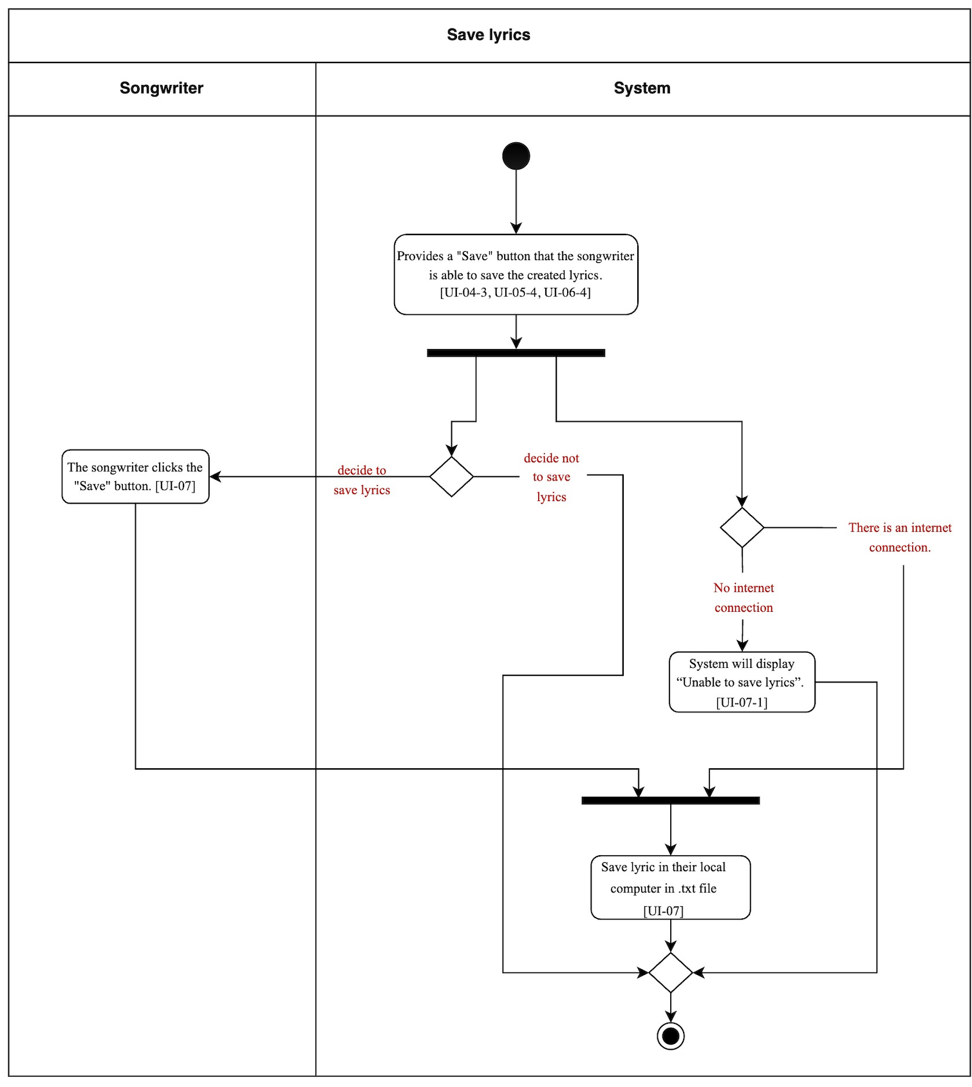
Document  Name | Artistverse-SRS V.3.0 | Owner | NS , WS | Page | 40
Document  Type | Software Requirement  Specification | Release Date | 11/10/2024 | Print date | 11/10/2024

2.1.3.7 UCD-07 |  | can | capture | facial | expressions | to | detect | mood | and received
URS-07: | Songwriter
recommended song
●  ●  ●  ●  ●  ●  ●  ●  ●  ●  ●  ●  ● | SRS-33: The system shall display a "Camera Mood" page [UI-08]  SRS-34: The system will display a message to ask permission for the camera accessincluding allow and deny.  SRS-35: The system shall display the camera view. [UI-08-1]  SRS-36: The system shall receive the facial expression of the songwriter and providethe reset button to reset their mood and be able to capture again.  SRS-37: The system shall clear all the input if the songwriter wants to capture thefacial expression again.[UI-08-1]  SRS-38: The system shall analyze the facial expression to determine the Songwritermood.  SRS-39: The system shall display “Mood could not be detected, Try again”, if systemUnable to determine the Songwriter mood. [UI-08-2]  SRS-40: The system shall display the detected mood to the Songwriter.  SRS-41: The system request the song from specific mood playlist in spotify by usingspotifyAPI  SRS-42: The system will store the song by name,album,artist,image,spotify_link andemotion  SRS-43: The system will match the detected mood with song emotion  SRS-44: The system shall provide the reset button to reset their mood and be able tocapture again.if the songwriter want to reset recommend song and mood detection[UI-08-4]  ●  ●  ●  ●  ●  ●  ●  ●  ●  ●  ●  ●  SRS-45: The system shall display recommended songs based on the songwriter's
 | detected | mood | and | provide | spotify_link | ("Listen | on | spotify"button) | in | the
recommended songs on the playlist.[UI-08-4]
Use Case ID | UC-07
Use Case  name | Capture Facial Expression and Recommended Song
Created By | NS , WS | Last Update By | NS , WS
Data create | 10/05/2024 | Last revision | 29/05/2024
Actors | Songwriter
Description | This use case describes the process of capturing facial expressionsusing the mood detection camera to determine the songwriter's currentmood and get the recommended song based on facial expression.

Document  Name | Artistverse-SRS V.3.0 | Owner | NS , WS | Page | 41
Document  Type | Software Requirement  Specification | Release Date | 11/10/2024 | Print date | 11/10/2024

Trigger | The songwriter clicks on the "Camera Mood" page
Precondition  s | ● ● Songwriters have access to the website. Songwriter has granted permission for camera access. ●
Use Case Input Specification
Input | Type | Constraint |  | Example
Facial  expression | Image | Image captured by camera |  | Facial  expression of  the image are  “Happy” the  system will  detect the mood“Happy”
Post  conditions | Songwriter mood is detected and displayed on the camera view andget recommended songs based on their mood.
Normal  flows | User |  | System
 | 3.Clicks the "capture"  button. |  | 1.Display the camera mood page  [UI-08]  [1A: If the songwriter first time enterto camera mood page]  [1B: If the songwriter allow access tocamera]  [1C: If the songwriter deny access toallow camera]  2.Displays the camera view and  provide capture button [UI-08-1]  4.Receive the facial expression of thesongwriter and provide the reset  button to reset their mood and be ableto capture again.  [4A: If the songwriter want to capturethe facial expression again by clickingreset button]

Document  Name | Artistverse-SRS V.3.0 | Owner | NS , WS | Page | 42
Document  Type | Software Requirement  Specification | Release Date | 11/10/2024 | Print date | 11/10/2024

5.Analyzes the facial expression to
determine the Songwriter mood.
[5A: Unable to determine the
Songwriter mood]
6.Displays the detected mood to theSongwriter [UI-08-3]
7. Request the song from specific
mood playlist in spotify by using
spotifyAPI
8.Receive specific mood playlist byname,album,artist,image,
spotify_link and emotion
9.Store the song by
name,album,artist,image,
spotify_link and emotion
10.Match the detected mood with songemotion
11.Display recommend songs basedon the songwriter's detected mood andprovide spotify_link ("Listen on
spotify" button) in the recommendedsongs on the playlist.[UI-08-4]
[11A: If songwriter want to reset
recommend song and mood detectionby clicking reset button]
Alternate  Flow | [1A: If the songwriter first time enter to camera mood page]  1. System will display a message to ask permission for the camera  access including allow and deny.  2. Go to 1B or 1C  [1B: If the songwriter allow access to camera]  1. Go to normal flow 2  [4A: If the songwriter want to capture the facial expression againby clicking reset button]

Document  Name | Artistverse-SRS V.3.0 | Owner | NS , WS | Page | 43
Document  Type | Software Requirement  Specification | Release Date | 11/10/2024 | Print date | 11/10/2024

1. The songwriter Clicks the "reset" button.
2. The system shall clear all the input. [UI-08-3]
3. Go to normal flow 2
[5A: Unable to determine the Songwriter mood]
1. The system shall display “Mood could not be detected, Try
again”, if system unable to determine the Songwriter mood.[UI-08-2]
2. Go to normal flow 2
[11A: If songwriter want to reset recommend song and mood
detection by clicking reset button]
1. The songwriter Clicks the "reset" button.
2. The system shall clear all the input if the songwriter wants to
capture the facial expression again. [UI-08-1]
3. Go to normal flow 2
Exception  Flow | [1C: If the songwriter deny access to allow camera]  1. Flow end in failure case
Assumption | Songwriter device has a functional camera.

Document  Name | Artistverse-SRS V.3.0 | Owner | NS , WS | Page | 44
Document  Type | Software Requirement  Specification | Release Date | 11/10/2024 | Print date | 11/10/2024

AD-07: Capture Facial Expression and Recommended Song
The Capture Facial Expression and Recommended Song activity diagram will show
the activity flow of the songwriter having access to the camera and capturing the facialexpression into the system to receive the recommended song.
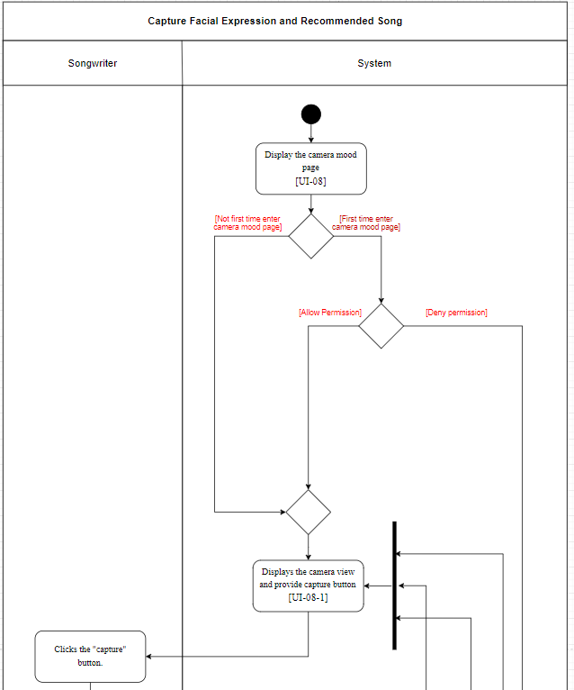
Document  Name | Artistverse-SRS V.3.0 | Owner | NS , WS | Page | 45
Document  Type | Software Requirement  Specification | Release Date | 11/10/2024 | Print date | 11/10/2024

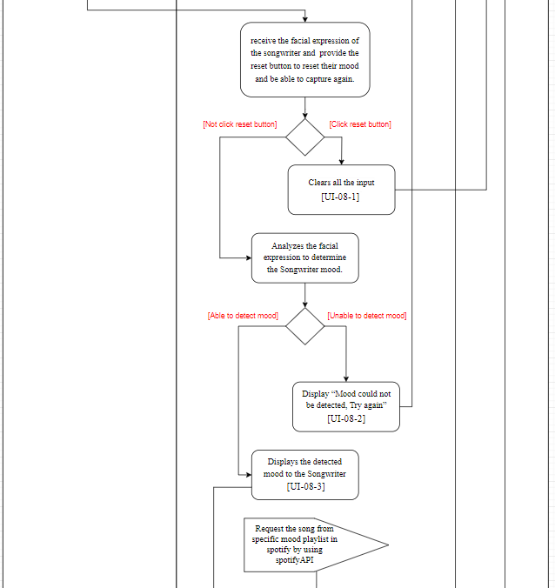
Document  Name | Artistverse-SRS V.3.0 | Owner | NS , WS | Page | 46
Document  Type | Software Requirement  Specification | Release Date | 11/10/2024 | Print date | 11/10/2024

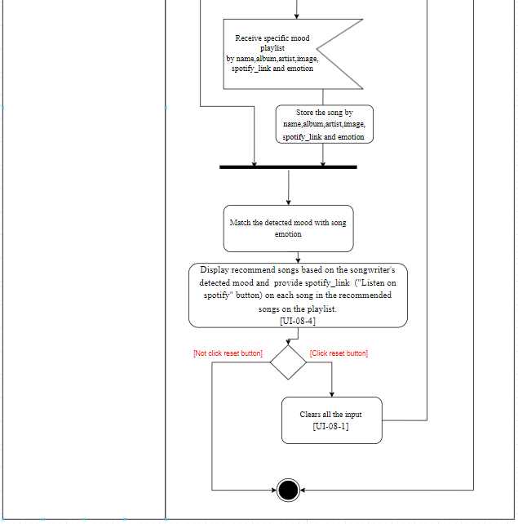
Document  Name | Artistverse-SRS V.3.0 | Owner | NS , WS | Page | 47
Document  Type | Software Requirement  Specification | Release Date | 11/10/2024 | Print date | 11/10/2024

2.1.3.8 UCD-08
URS-08: Songwriter can select song from recommended song in playlist to listen in spotify
● | SRS-46: The system will get spotify_link of each song from database of the song that
 | Songwriter selected
● | SRS-47: The system shall redirected Songwriter to Spotify interface by using
 | spotify_link

Use Case  ID | UC-08
Use Case  name | Select Song to Listen on Spotify Platform
Created  By | NS , WS | Last Update By | NS , WS
Data  create | 10/05/2024 | Last revision | 29/05/2024
Actors | Songwriter
Descripti  on | This use case describes the process of selecting a song from the  recommended playlist to listen to on the Spotify platform.
Trigger | Songwriter Selects a song by clicking spotify_link ("Listen on spotify"button) in the recommended songs on the playlist.
Precondit  ions | UC-06
Use Case Input Specification
Input | Type | Constraint | Example
Selected  song | String | Song selected by the songwriter | "Believer -  Imagine  dragon"
Post  condition  s | ● Songwriters are redirected to the Spotify application to listen to theirselected song.

Document  Name | Artistverse-SRS V.3.0 | Owner | NS , WS | Page | 48
Document  Type | Software Requirement  Specification | Release Date | 11/10/2024 | Print date | 11/10/2024

Normal  flows | User | System
1.Get spotify_link of each song from
database of the song that Songwriter
selected
2.Redirected Songwriter to Spotify
interface by using spotify_link
Alternate  Flow | -
Exception  Flow | -
Assumpti  on | The songwriter has an internet connection to listen their song on spotifyplatform

Document  Name | Artistverse-SRS V.3.0 | Owner | NS , WS | Page | 49
Document  Type | Software Requirement  Specification | Release Date | 11/10/2024 | Print date | 11/10/2024

AD-08: Select Song
The Select Song activity diagram will show the activity flow of the songwriter
received the recommended song based on songwriter mood and can redirected to the spotifyplatform
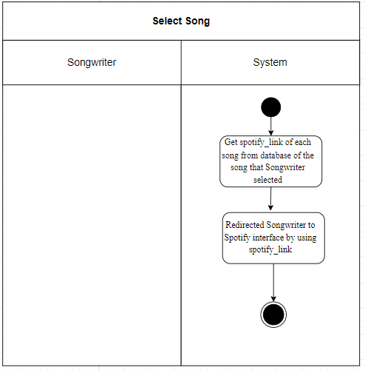
Document  Name | Artistverse-SRS V.3.0 | Owner | NS , WS | Page | 50
Document  Type | Software Requirement  Specification | Release Date | 11/10/2024 | Print date | 11/10/2024

2.2.3 Use Case Description and Activity Diagram
2.2.3.09 UCD-09 : Access and View Chord Progression Information
URS-09: The songwriter can access the "Chord Progression" page to view information,selecting from the navigation options provided in SRS-02.
●  ●  ● | SRS-48: The system shall display the "Chord Progression" page [UI-09] that includesintroductory information about "What is a Chord Progression?" and lists availablechord progressions (2-5-1-6, 1-6-2-5, 1-5-6-4, 1-6-4-5, 1-4-5-1, 1-4-6-5, 1-6-2-6,6-4-3-2).  SRS-49: The system shall provide a "Back" button [UI-09] on the detailed chordprogression information page to allow the songwriter to return to the previous page orthe main "Chord Progression" page.  SRS-50: The system shall provide a "Next" button [UI-09] on the detailed chordprogression information page to allow the songwriter to navigate between differentchord progression details [UI-09-1].  ●  ●  ●

Use Case ID | UC-09
Use Case  name | Access and View Chord Progression Information
Created By | NS, WS | Last Update By | NS, WS
Data create | 10/08/2024 | Last revision | 30/08/2024
Actors | Songwriter
Description | This use case describes how the songwriter accesses the "ChordProgression" page to view detailed information about chord  progressions, including an introduction and a list of available  progressions.
Trigger | The songwriter selects the "Chord Progression" option from thedrop-down menu in the navigation bar, as provided in SRS-02.  [UI-02]
Preconditions | The system has loaded the "navbar-toggler-icon" and the drop-downmenu as described in SRS-02. [UI-02]
Use Case Input Specification
Input | Type | Constraint | Example
- | - | - | -

Document  Name | Artistverse-SRS V.3.0 | Owner | NS , WS | Page | 51
Document  Type | Software Requirement  Specification | Release Date | 11/10/2024 | Print date | 11/10/2024

Post  conditions | The songwriter is directed to the "Chord Progression" page  displaying introductory information and a list of available chordprogressions. [UI-09]
Normal flows | User | System
 | 1. Select "Chord  Progression" from the  dropdown menu. | 2. Display the "Chord Progression" pagethat includes introductory informationabout "What is a Chord Progression?"and lists available chord progressions(2-5-1-6,1-6-2-5,1-5-6-4,1-6-4-5,1-4-5-1,1-4-6-5, 1-6-2-6, 6-4-3-2). [UI-09]  (5A: If the songwriter wants to view thenext chord progression by clicking thenext button.)  (5B: If the songwriter wants to go backto the previous chord progression or  main page by clicking the back button.)
Alternate  Flow | [5A: If the songwriter wants to view the next chord progression]  1. The songwriter Clicks the next button.  2. Displays the next chord progression. [UI-09-1]  3. Go to normal flow 5  [5B: If the songwriter wants to go back to the previous chord  progression or main page by clicking the back button]  1. The songwriter Clicks the back button.  2. Displays the previous chord progression or returns to the main  page. [UI-09]  3. Go to normal flow 5
Exception  Flow | -
Assumption | The songwriter has an internet connection

Document  Name | Artistverse-SRS V.3.0 | Owner | NS , WS | Page | 52
Document  Type | Software Requirement  Specification | Release Date | 11/10/2024 | Print date | 11/10/2024

AD-09: Access and View Chord Progression Information
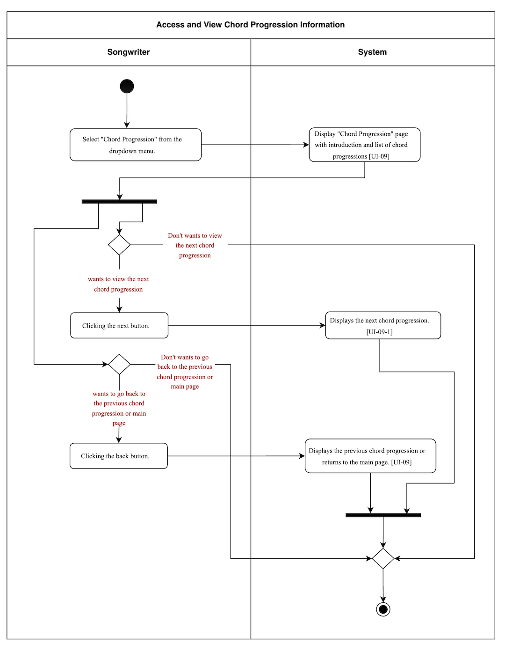
Document  Name | Artistverse-SRS V.3.0 | Owner | NS , WS | Page | 53
Document  Type | Software Requirement  Specification | Release Date | 11/10/2024 | Print date | 11/10/2024

2.2.3.10 UCD-10: View and interact the chord progression chart
URS-10: The songwriter can view the chord progression chart after accessing the "ChordProgression" page.
● | SRS-51: | The | system | shall | display | a | "CLICK | HERE | TO | SEE | CHORD
PROGRESSION CHART" button on UI-09 when the songwriter accesses the "ChordProgression" page. [UI-09]
●  ●  ●  ●  ● | SRS-52: After the "CLICK HERE TO SEE CHORD PROGRESSION CHART"button is clicked on UI-09, the system shall navigate to a new page that displays achart showing various chord progressions (2-5-1-6, 1-6-2-5, 1-5-6-4, 1-6-4-5, 1-4-5-1,1-4-6-5, 1-6-2-6, 6-4-3-2) and their keys (C, D, E, F, G, A, B). [UI-10]  SRS-53: The system shall allow the songwriter to select any progression from thetable. After selection, the system shall highlight the selected progression and key inyellow. [UI-10-1]  SRS-54: After a chord progression is selected, the system shall display a series chordof guitar diagrams corresponding to the selected progression below the table.[UI-10-1]  SRS-55: The system shall provide sound [UI-10-1] for the songwriter to listen to thepiano audio playback of the selected chord progression if the "sound" button isclicked. [UI-10-2]  SRS-56: The system shall allow the songwriter to change their selection chord ofguitar, updating the highlighted progression and the displayed chord diagramsaccordingly.  ●  ●  ●  ●  ●

Use Case ID | UC-10
Use Case  name | View and interact the chord progression chart
Created By | NS, WS | Last Update By | NS, WS
Data create | 10/08/2024 | Last revision | 30/08/2024
Actors | Songwriter
Description | This use case describes how a songwriter interacts with the "ChordProgression" page. The songwriter can view, select, and listen tovarious chord progressions within a chart.
Trigger | The songwriter accesses the "Chord Progression" page and clicks the"CLICK HERE TO SEE CHORD PROGRESSION CHART" button.[UI-09]
Preconditions | UC-09
Use Case Input Specification
Input | Type | Constraint | Example

Document  Name | Artistverse-SRS V.3.0 | Owner | NS , WS | Page | 54
Document  Type | Software Requirement  Specification | Release Date | 11/10/2024 | Print date | 11/10/2024

- | - | - |  | -
Post  conditions | The selected chord progression is highlighted in yellow, with  corresponding chord diagrams displayed below the chart and audioplayback provided for the selected progression. [UI-10-1]
Normal flows | User |  | System
 | 2. Click on the "CLICK  HERE TO SEE CHORD  PROGRESSION CHART"button.  4. Select any progression  from the table.  (2-5-1-6, 1-6-2-5, 1-5-6-4,  1-6-4-5, 1-4-5-1, 1-4-6-5,  1-6-2-6, 6-4-3-2). |  | 1. The system displays "CLICK HERETO SEE CHORD PROGRESSION  CHART" button [UI-09]  3. The system displays a chart showingvarious chord progressions and keys.  [UI-10]  5. The system highlights the selected  progression and key in yellow.  [UI-10-1]  6. The system displays a series chord ofguitar diagrams corresponding to the  selected progression below the table.  [UI-10-1]  (6A: If the songwriter wants to select  by selecting any progression from thetable. )  (6B: If the songwriter wants to listen tothe piano audio playback of the  selected chord progression by clickingthe "sound" button)
Alternate  Flow | [6A: If the songwriter wants to select by selecting any progressionfrom the table.]  1. Go to normal flow 4.  [6B: If the songwriter wants to listen to the piano audio playbackof the selected chord progression by clicking the "sound" button]

Document  Name | Artistverse-SRS V.3.0 | Owner | NS , WS | Page | 55
Document  Type | Software Requirement  Specification | Release Date | 11/10/2024 | Print date | 11/10/2024

1. The system provides sound for the piano audio playback of the
selected chord progression.
2. The use case ends.
Exception  Flow | -
Assumption | The songwriter has an internet connection

Document  Name | Artistverse-SRS V.3.0 | Owner | NS , WS | Page | 56
Document  Type | Software Requirement  Specification | Release Date | 11/10/2024 | Print date | 11/10/2024

AD-10: View and interact the chord progression chart
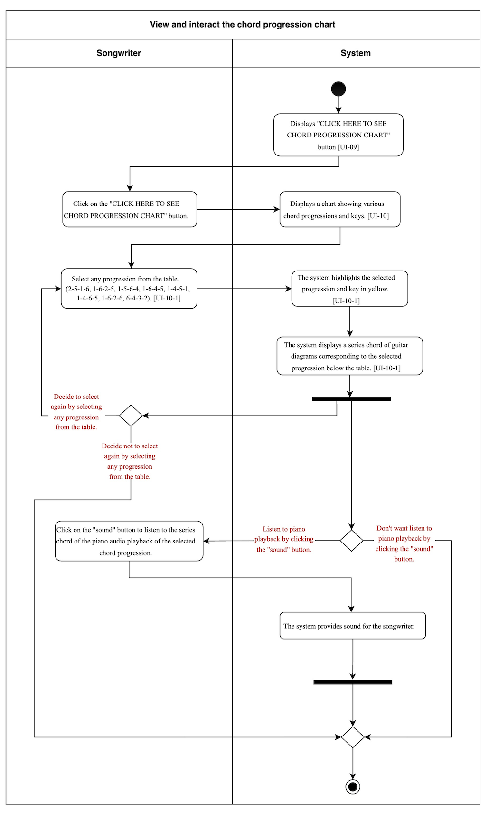
Document  Name | Artistverse-SRS V.3.0 | Owner | NS , WS | Page | 57
Document  Type | Software Requirement  Specification | Release Date | 11/10/2024 | Print date | 11/10/2024

2.2.3.11 UCD-11: Input Lyrics and View Musical Analysis
URS-11: The songwriter can input lyrics into a text field and view a detailed musical analysisbased on the lyrics input, selecting from the navigation options provided in SRS-02.
●  ●  ●  ●  ●  ●  ● | SRS-57: The system shall display a "AI Analysis" page [UI-11]  SRS-58: The system shall provide a text field for the songwriter to input lyrics.  SRS-59: The system shall analyze the input lyrics and chords, tempo, time signature,keys, and extracts musical information based on the provided lyrics. [UI-11-2]  SRS-60: If the songwriter attempts to proceed without completing the input lyricsfields, the system shall display an error message indicating the missing fields. Theerror message will state: "The lyrics field cannot be empty. Enter your lyrics toproceed." [UI-11-1]  SRS-61: If there is no internet connection, the system shall display an error message"Internet no connection" [UI-11-3]  SRS-62: The system shall allow the songwriter to analyze new lyrics by filling in thetext field again on the AI Analysis page.  SRS-63: The system shall display the results of the analysis to the songwriter basedon the input lyrics. [UI-11-5]  ●  ●  ●  ●  ●  ●  ●

Use Case ID | UC-13
Use Case  name | Input Lyrics and View Musical Analysis
Created By | NS, WS | Last Update By | NS, WS
Data create | 10/08/2024 | Last revision | 30/08/2024
Actors | Songwriter
Description | This use case describes the process through which the songwriter caninput lyrics into a text field and receive a detailed musical analysisbased on the input lyrics.
Trigger | The songwriter clicks on the "AI Analysis" page. [UI-02]
Preconditions | The system has loaded the "navbar-toggler-icon" and the drop-downmenu as described in SRS-02. [UI-02]
Use Case Input Specification
Input | Type | Constraint | Example
Lyrics | Text | Required | In the quiet night,  under the moon's  soft glow,

Document  Name | Artistverse-SRS V.3.0 | Owner | NS , WS | Page | 58
Document  Type | Software Requirement  Specification | Release Date | 11/10/2024 | Print date | 11/10/2024

We dance through
the dark, where
dreams freely flow.Your hand in mine,we’ll reach for the
skies,
With every
heartbeat, our love
never dies.
Through the
shadows and light,
we’ll find our way,In the whispers of
dawn, where night
turns to day.
Together we’ll soar,on wings made of
dreams,
In this endless
journey, nothing’s asit seems.
Every star that we
chase, will guide usthrough,
In the canvas of
night, painted just
for you.
Hold on to me tight,let the magic unfold,In this story of love,we’re forever bold.
Post  conditions | The songwriter receives a detailed musical analysis including  suggested chords, recommended tempo, time signature, key  identification, and other relevant musical information. [UI-11-5]
Normal flows | User |  | System

Document  Name | Artistverse-SRS V.3.0 | Owner | NS , WS | Page | 59
Document  Type | Software Requirement  Specification | Release Date | 11/10/2024 | Print date | 11/10/2024

 | 3.The songwriter inputs  lyrics into the text field.  4.Click on the "Send"button to for analysislyrics. [UI-11-4] | 1.Display the AI Analysis page  2.Display the text field for lyrics input.  5. Check if all required input lyrics arecompleted and meet the constraints.  (5A: If the songwriter attempts to  proceed without completing input lyricsfields.)  6.The system displays the results of theanalysis lyrics to the songwriter.  (6A: Unable to displays the results of  the analysis lyrics causing by no  internet connection )  (6B: If the songwriter wants to analyzenew lyrics by filling lyrics in the text  field.)
Alternate  Flow | [5A: If the songwriter attempts to proceed without completinginput lyrics fields.]  1. the system will display an error message indicating the missing  fields.The error message will state: "The lyrics field cannot beempty. Enter your lyrics to proceed." [UI-11-1]  2. Go to normal flow 3.  [6B: If the songwriter wants to analyze new lyrics by filling lyricsin the text field.]  1. Go to normal flow 3.
Exception  Flow | [6A: Unable to displays the results of the analysis lyrics causing byno internet connection]  1. The system will display “Internet no connection” [UI-11-3]2. The use case ends.
Assumption | The songwriter has an internet connection

Document  Name | Artistverse-SRS V.3.0 | Owner | NS , WS | Page | 60
Document  Type | Software Requirement  Specification | Release Date | 11/10/2024 | Print date | 11/10/2024

AD-11: Input Lyrics and View Musical Analysis
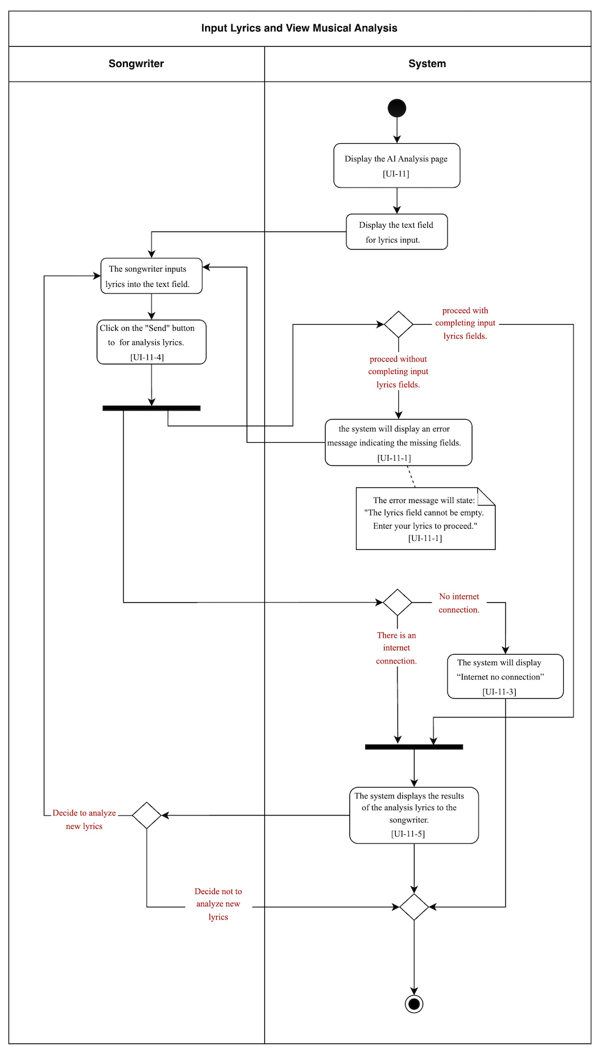
Document  Name | Artistverse-SRS V.3.0 | Owner | NS , WS | Page | 61
Document  Type | Software Requirement  Specification | Release Date | 11/10/2024 | Print date | 11/10/2024

2.2.3.12 UCD-12: Save Analyzed Lyrics
URS-12: The songwriter can save information as a .txt file on their local computer afteranalyzing the input lyrics.
●  ●  ● | SRS-64: The system shall provide a "Save" button that allows the songwriter to savethe analyzed lyrics information.  SRS-65: The system shall save the analyzed lyrics information to the songwriter'slocal computer in a .txt file format. [UI-11-6]  SRS-66: If there is no internet connection, the system shall display an error message"No internet connection" [UI-11-7]  ●  ●  ●

Use Case ID | UC-14
Use Case  name | Save Analyzed Lyrics
Created By | NS, WS | Last Update By |  | NS, WS
Data create | 10/08/2024 | Last revision |  | 30/08/2024
Actors | Songwriter
Description | This use case describes the process through which the songwriter cansave the analyzed lyrics information as a .txt file on their local  computer.
Trigger | The songwriter clicks the "Save" button after the lyrics analysis hasbeen displayed.
Preconditions | UC-11
Use Case Input Specification
Input | Type | Constraint |  | Example
Save action | button | User-initiated |  | Clicking "Save"
Post  conditions | The analyzed lyrics information are saved as a .txt file on the  songwriter's local computer. [UI-11-6]
Normal flows | User |  | System

Document  Name | Artistverse-SRS V.3.0 | Owner | NS , WS | Page | 62
Document  Type | Software Requirement  Specification | Release Date | 11/10/2024 | Print date | 11/10/2024

 | 2.Clicks the "Save" button. | 1.Provides a "Save" button that the  songwriter can save the analyzed lyricsinformation.  3.Saves the analyzed lyrics informationon their local computer in .txt file.  (3A: Unable to save the analyzed lyricsinformation causing by no internet  connection )
Alternate  Flow | -
Exception  Flow | [3A: Unable to save the analyzed lyrics information causing by nointernet connection]  1. The system will display “No internet connection” [UI-11-7]2. The use case ends.
Assumption | The songwriter has an internet connection

Document  Name | Artistverse-SRS V.3.0 | Owner | NS , WS | Page | 63
Document  Type | Software Requirement  Specification | Release Date | 11/10/2024 | Print date | 11/10/2024

AD-12: Save Analyzed Lyrics
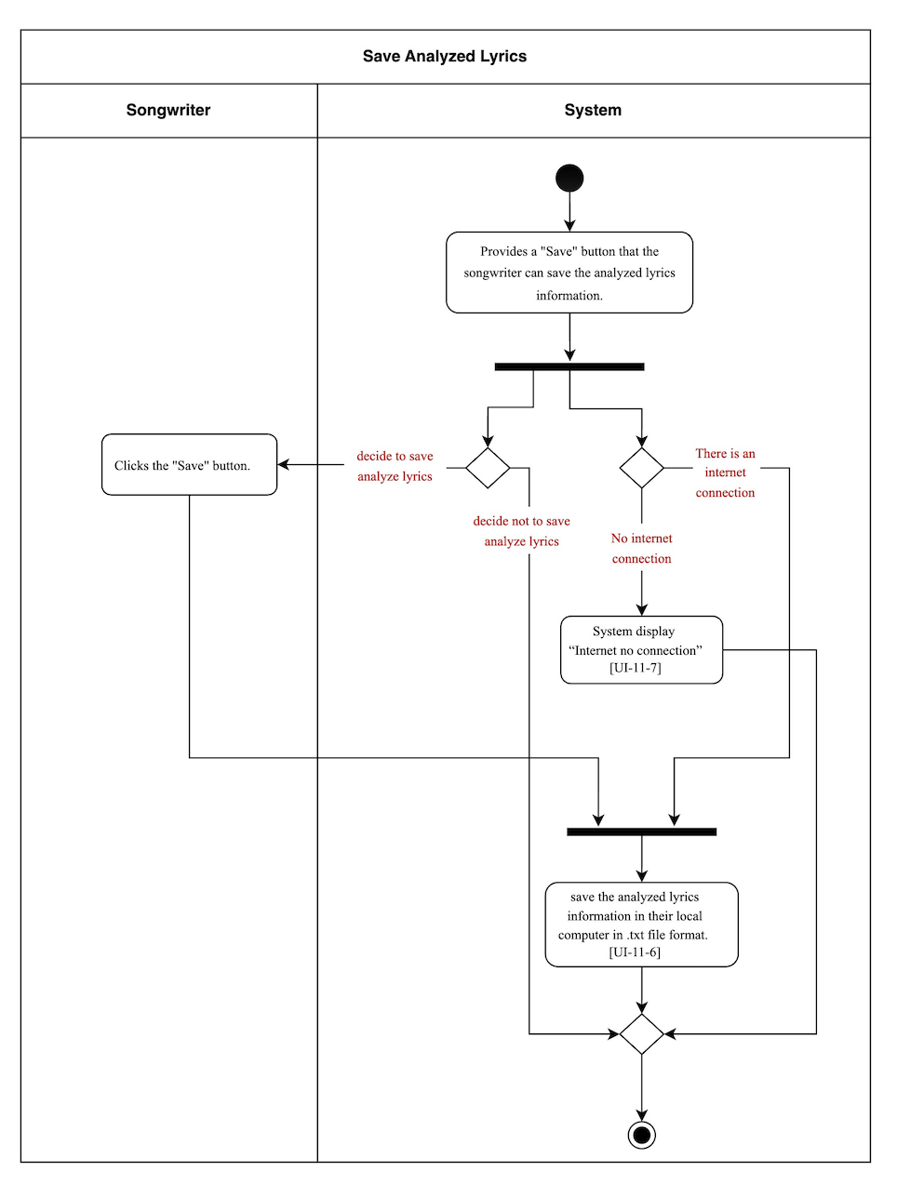
Document  Name | Artistverse-SRS V.3.0 | Owner | NS , WS | Page | 64
Document  Type | Software Requirement  Specification | Release Date | 11/10/2024 | Print date | 11/10/2024

APPENDIX UI
UI-01 Home page
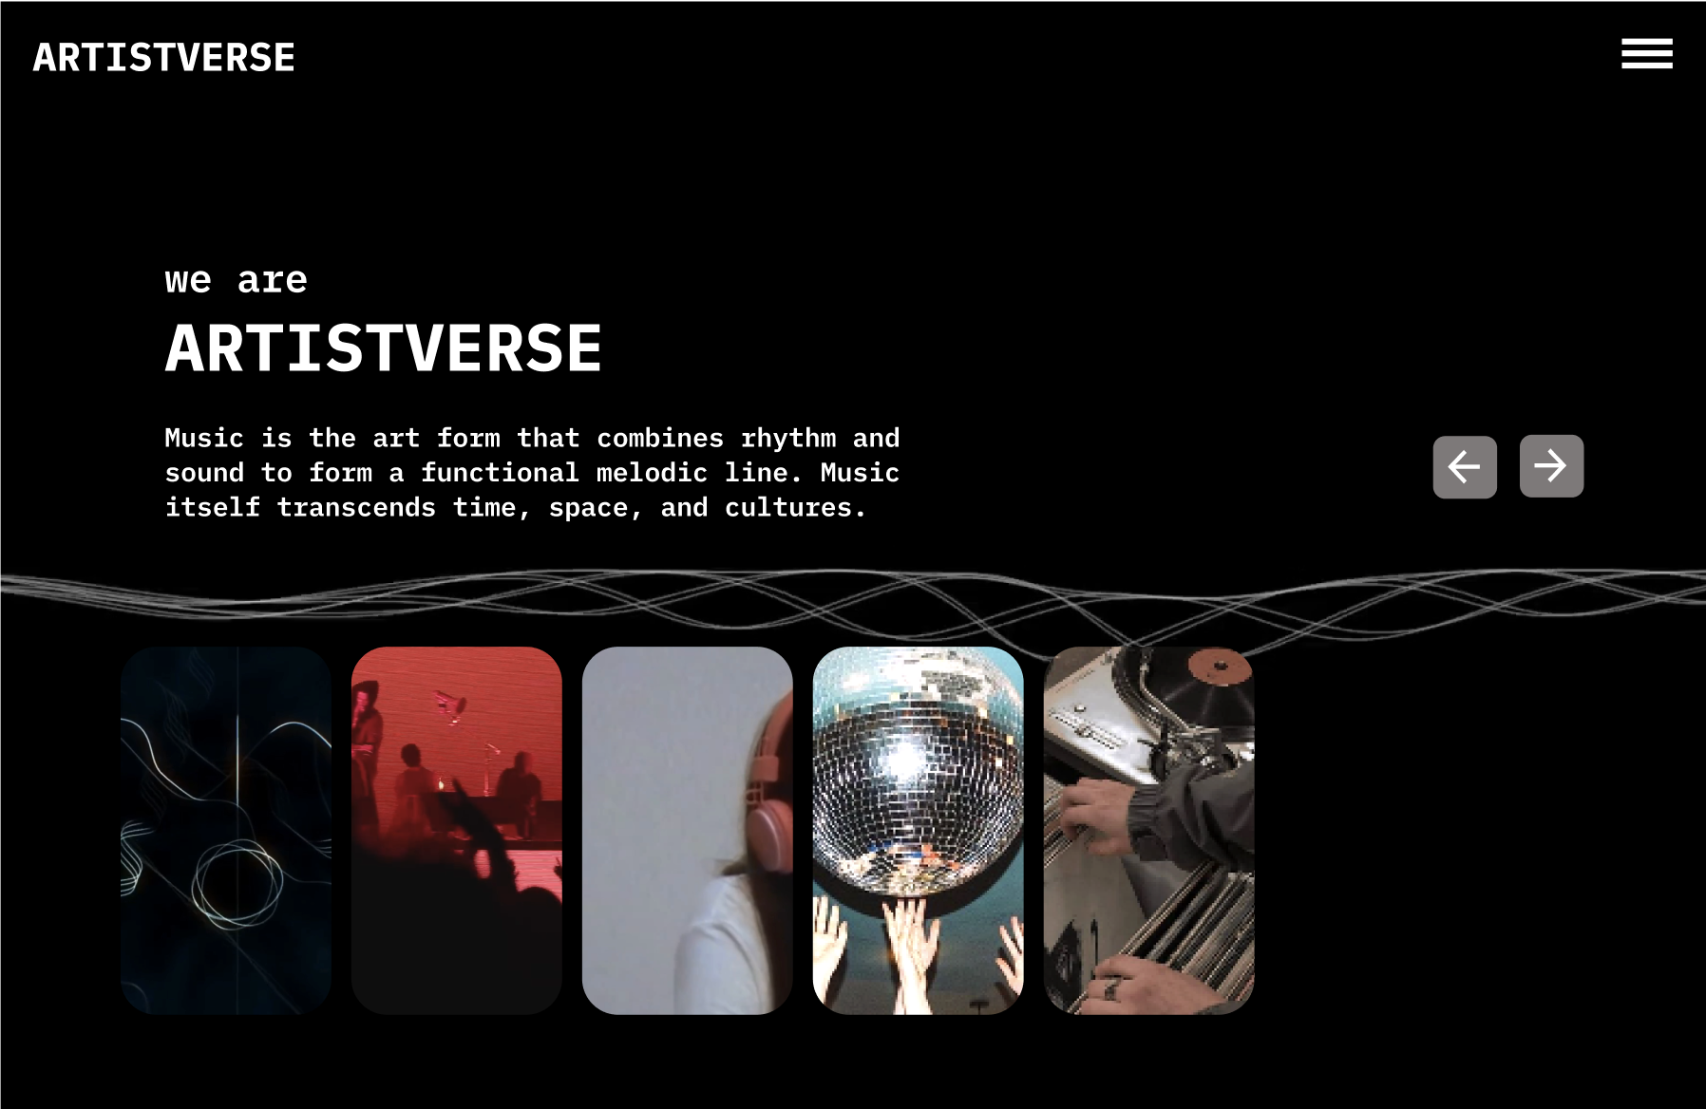
UI-02 Home page with "navbar-toggler-icon" button
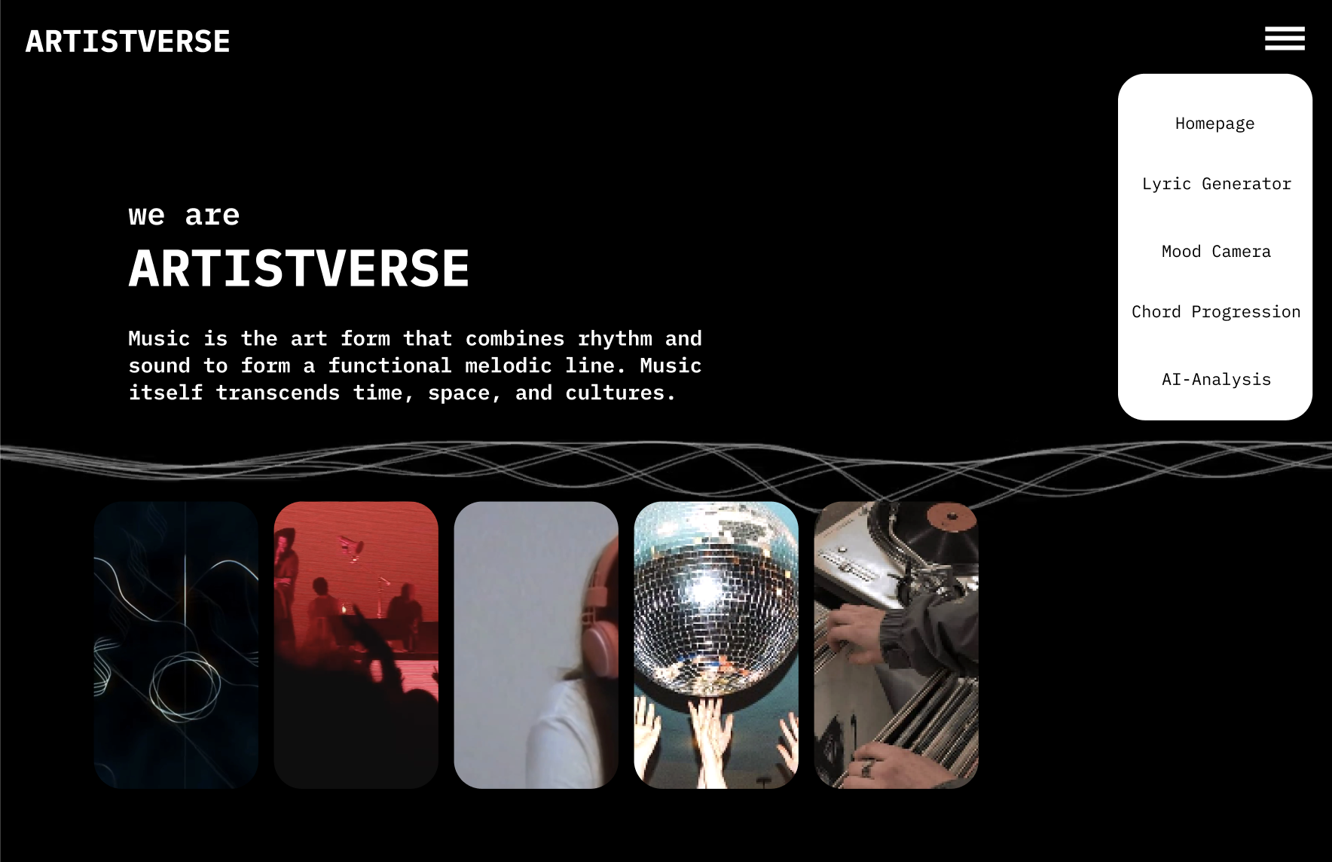
Document  Name | Artistverse-SRS V.3.0 | Owner | NS , WS | Page | 65
Document  Type | Software Requirement  Specification | Release Date | 11/10/2024 | Print date | 11/10/2024

UI-03 Lyric Generator page with "Let’s generate" button that can
redirect the Songwriter to the lyrics generator by Genre page and
information about including the Non-thai artist.
x
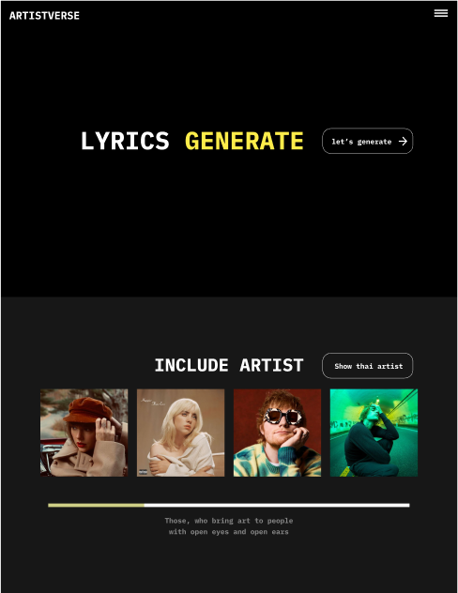
Document  Name | Artistverse-SRS V.3.0 | Owner | NS , WS | Page | 66
Document  Type | Software Requirement  Specification | Release Date | 11/10/2024 | Print date | 11/10/2024

UI-03-1 Lyric Generator page with "Let’s generate" button that can
redirect the Songwriter to the lyrics generator by Genre page and
information about including the Thai artist.
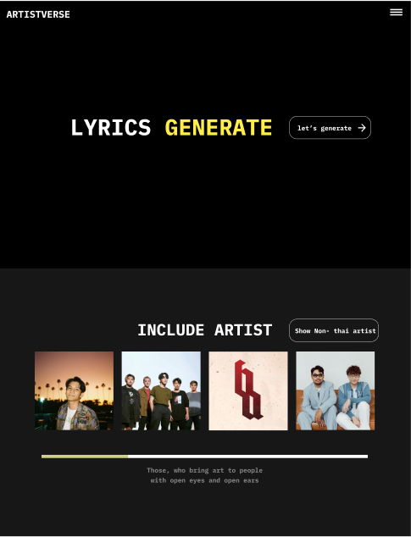
Document  Name | Artistverse-SRS V.3.0 | Owner | NS , WS | Page | 67
Document  Type | Software Requirement  Specification | Release Date | 11/10/2024 | Print date | 11/10/2024

UI-04 Lyric Generator by Genre Page
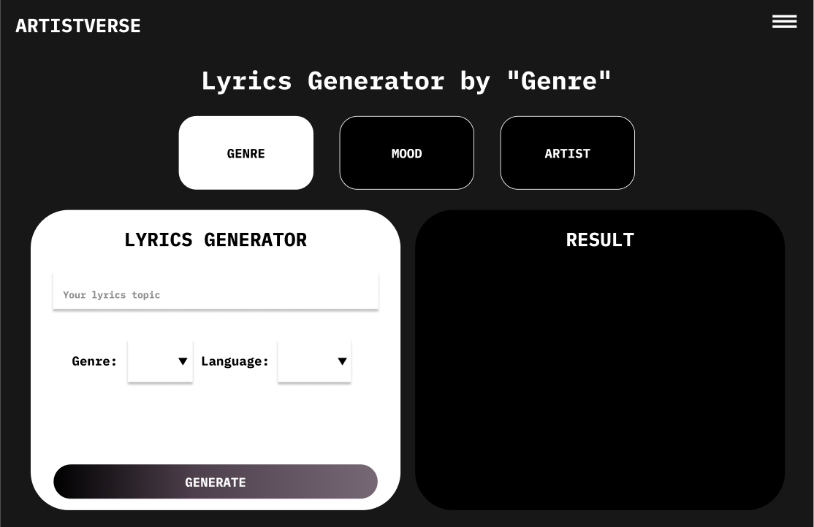
UI-04-1 With invalid input
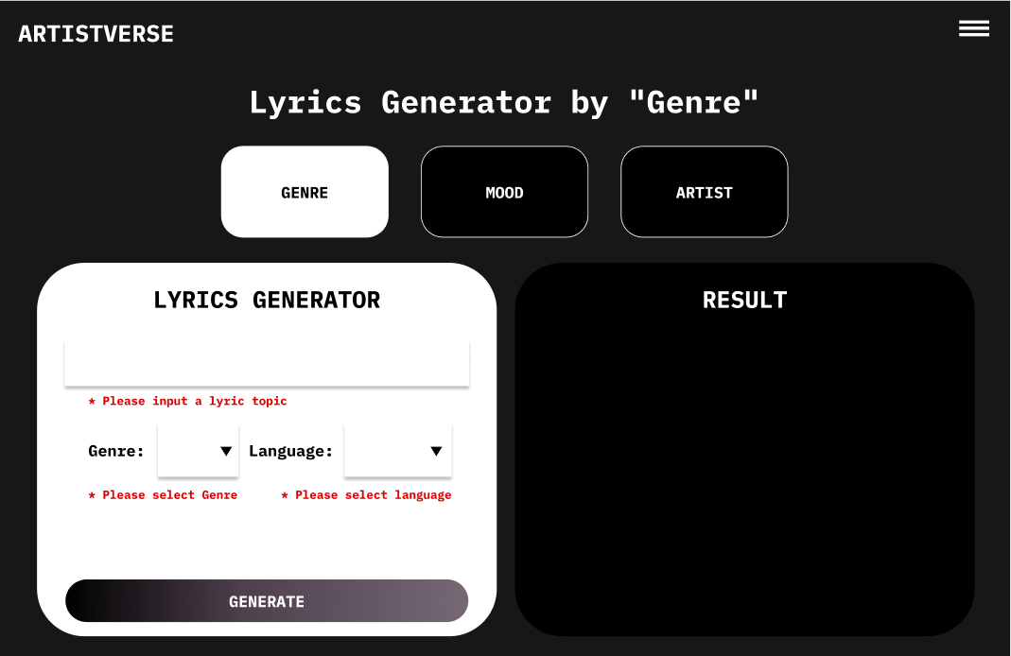
Document  Name | Artistverse-SRS V.3.0 | Owner | NS , WS | Page | 68
Document  Type | Software Requirement  Specification | Release Date | 11/10/2024 | Print date | 11/10/2024

UI-04-2 With input information
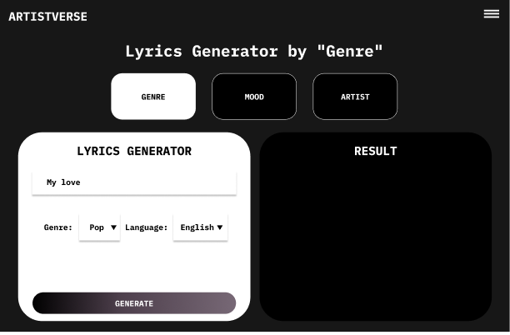
UI-04-3 With display the created lyrics
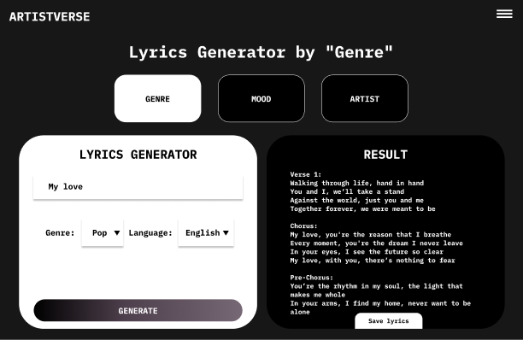
Document  Name | Artistverse-SRS V.3.0 | Owner | NS , WS | Page | 69
Document  Type | Software Requirement  Specification | Release Date | 11/10/2024 | Print date | 11/10/2024

UI-04-4 With causing by no internet connection
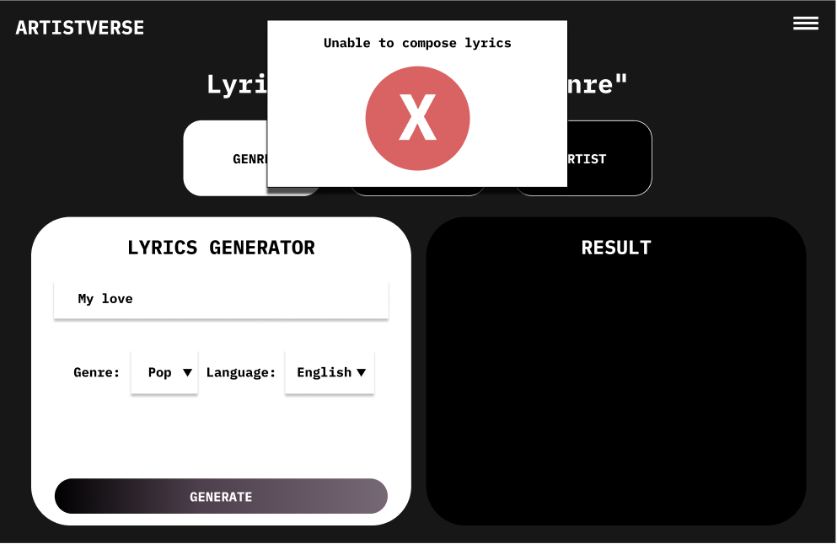
UI-05 Lyric Generator by Mood page
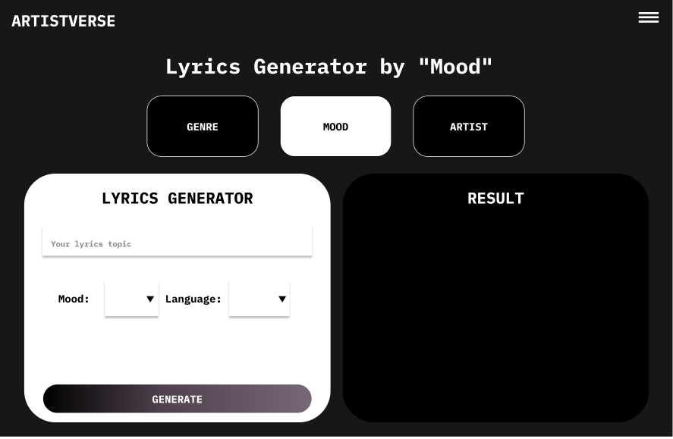
Document  Name | Artistverse-SRS V.3.0 | Owner | NS , WS | Page | 70
Document  Type | Software Requirement  Specification | Release Date | 11/10/2024 | Print date | 11/10/2024

UI-05-1 With input information
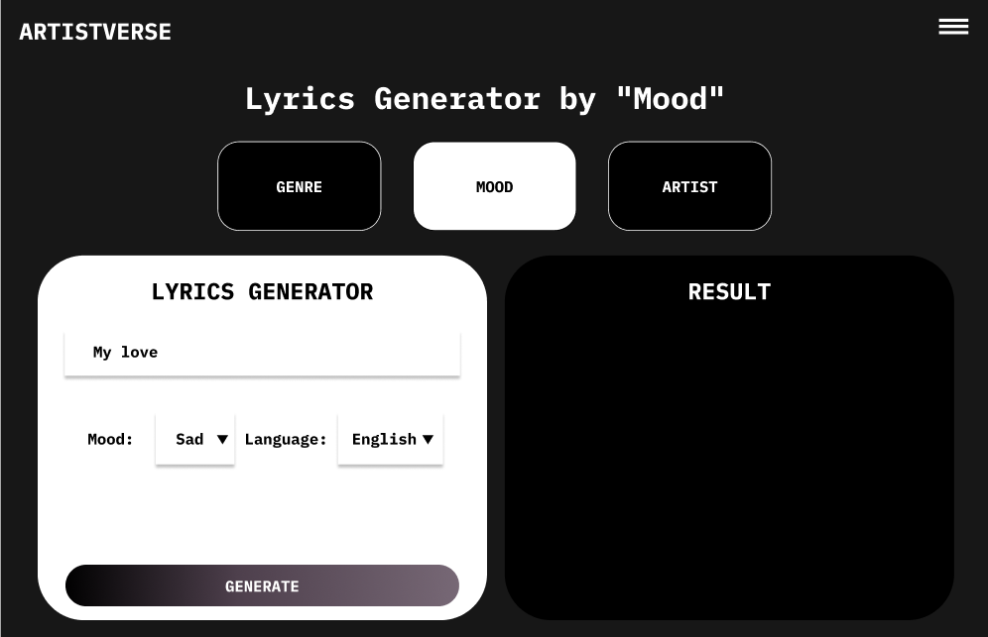
UI-05-2 With invalid input
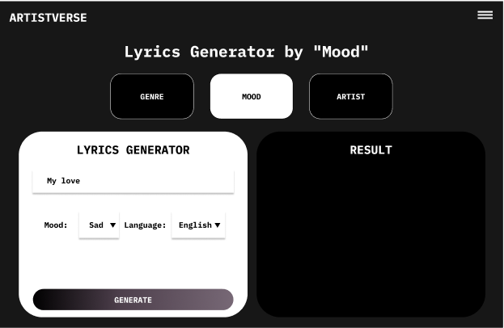
Document  Name | Artistverse-SRS V.3.0 | Owner | NS , WS | Page | 71
Document  Type | Software Requirement  Specification | Release Date | 11/10/2024 | Print date | 11/10/2024

UI-05-3 With causing by no internet connection
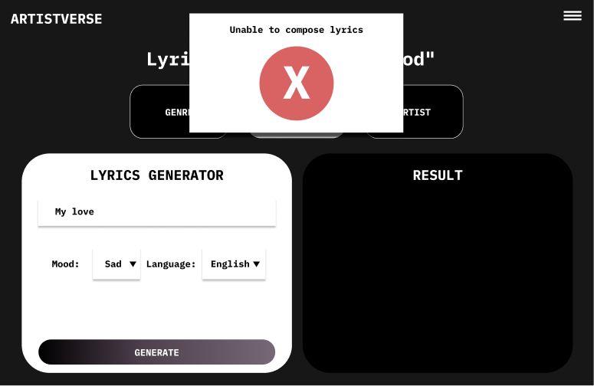
UI-05-4 With display the created lyrics
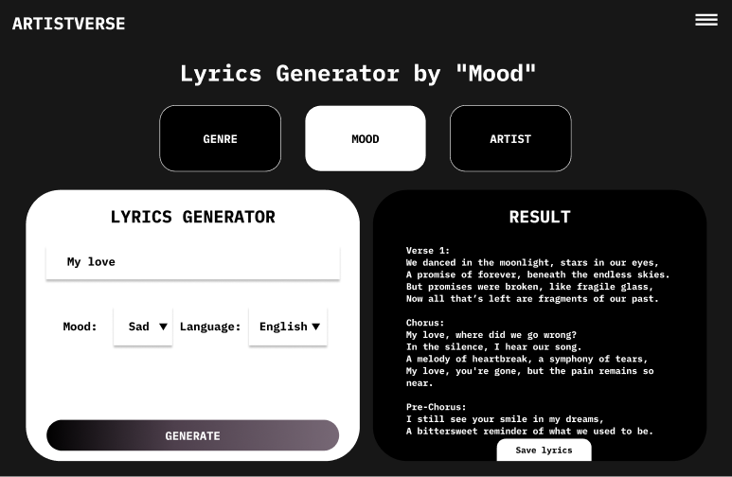
Document  Name | Artistverse-SRS V.3.0 | Owner | NS , WS | Page | 72
Document  Type | Software Requirement  Specification | Release Date | 11/10/2024 | Print date | 11/10/2024

UI-06 Lyric Generator by Style Artist Page
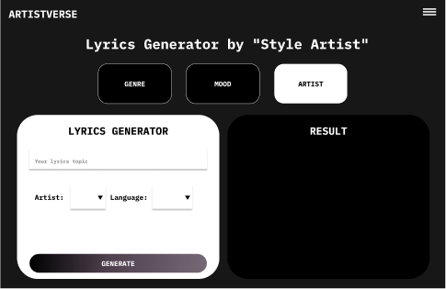
UI-06-1 With invalid input
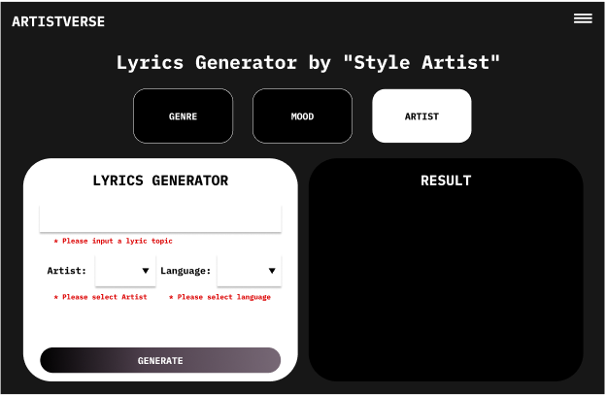
Document  Name | Artistverse-SRS V.3.0 | Owner | NS , WS | Page | 73
Document  Type | Software Requirement  Specification | Release Date | 11/10/2024 | Print date | 11/10/2024

UI-06-2 With input information
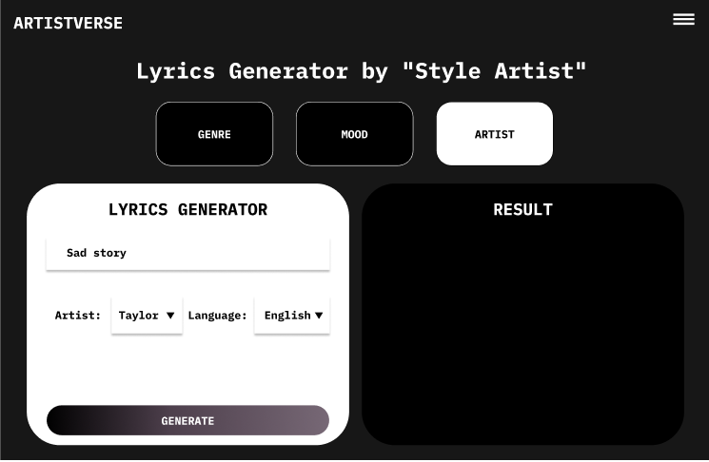
UI–06-3 With causing by no internet connection
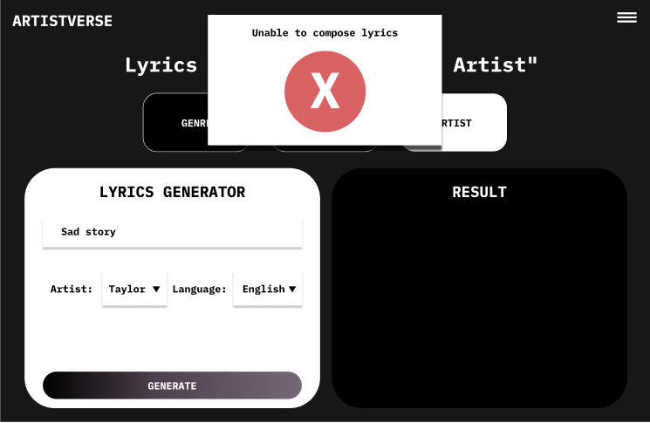
Document  Name | Artistverse-SRS V.3.0 | Owner | NS , WS | Page | 74
Document  Type | Software Requirement  Specification | Release Date | 11/10/2024 | Print date | 11/10/2024

UI-06-4 With display the created lyrics
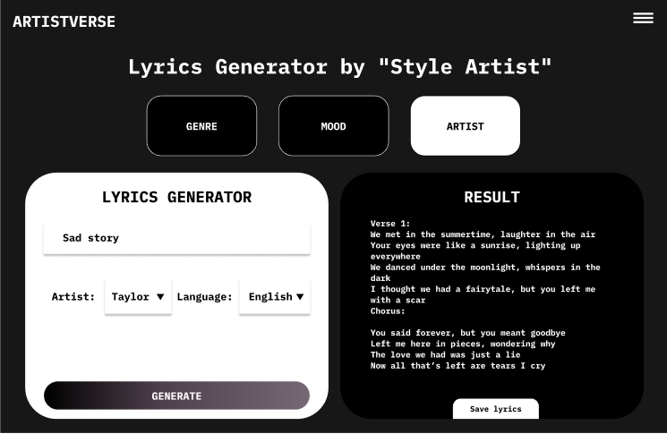
UI-07 Lyric Generator page with save lyrics
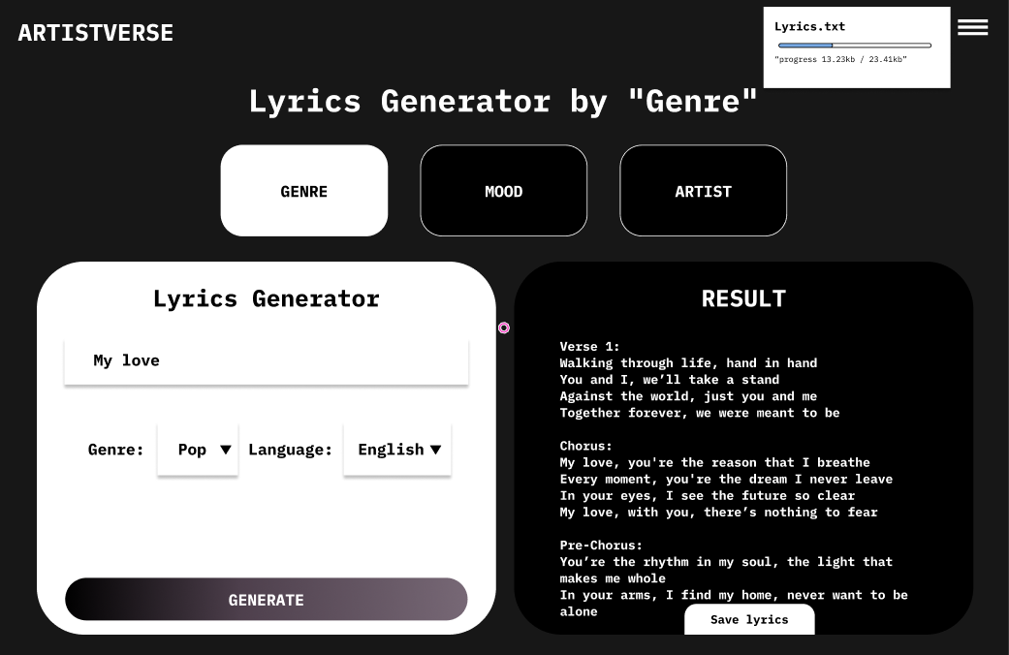
Document  Name | Artistverse-SRS V.3.0 | Owner | NS , WS | Page | 75
Document  Type | Software Requirement  Specification | Release Date | 11/10/2024 | Print date | 11/10/2024

UI-07-1 With Unable to save lyrics causing by no internet connection
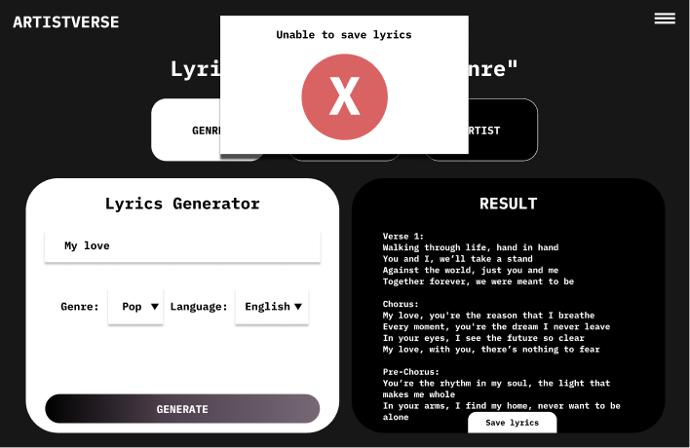
UI-08 Camera mood page
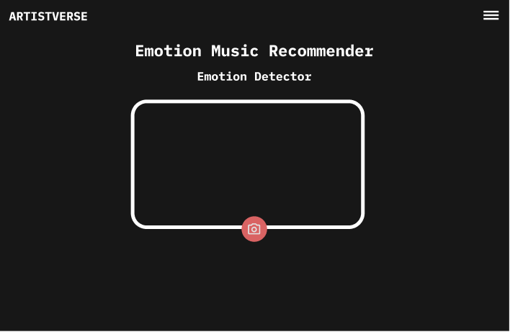
Document  Name | Artistverse-SRS V.3.0 | Owner | NS , WS | Page | 76
Document  Type | Software Requirement  Specification | Release Date | 11/10/2024 | Print date | 11/10/2024

UI-08-1 With camera view
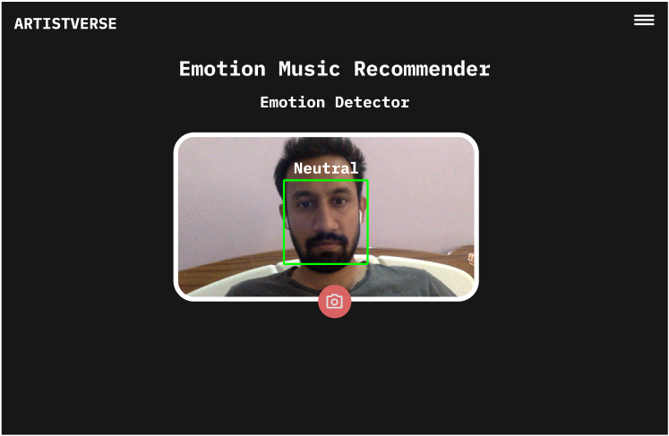
UI-08-2 With system unable to determine the mood
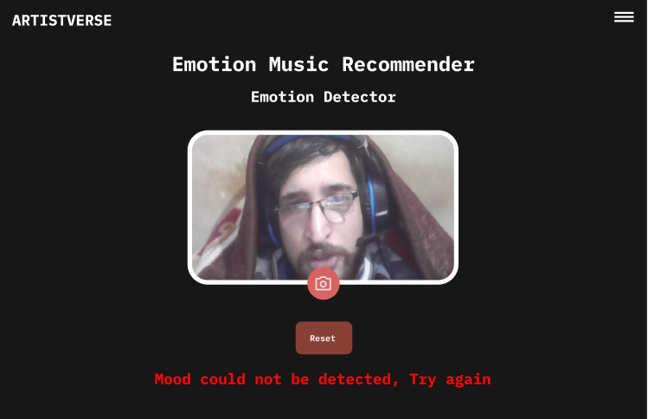
Document  Name | Artistverse-SRS V.3.0 | Owner | NS , WS | Page | 77
Document  Type | Software Requirement  Specification | Release Date | 11/10/2024 | Print date | 11/10/2024

UI-08-3 Camera mood page with detected mood
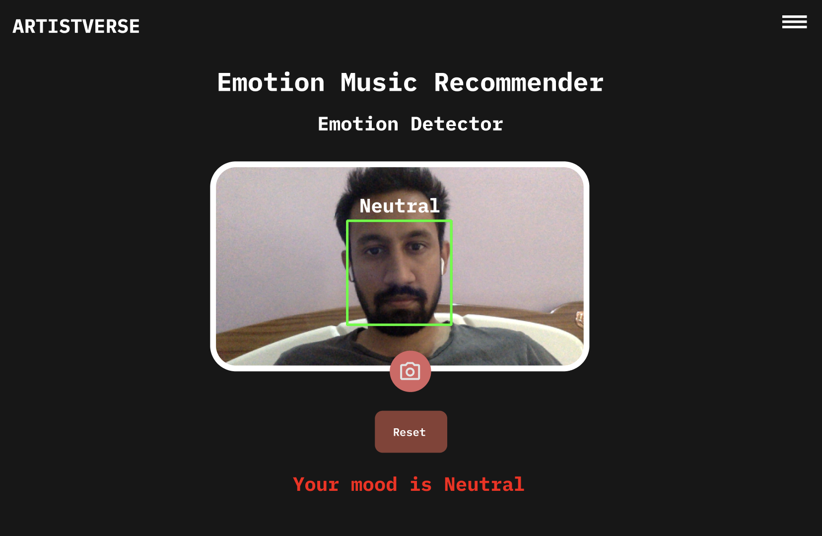
Document  Name | Artistverse-SRS V.3.0 | Owner | NS , WS | Page | 78
Document  Type | Software Requirement  Specification | Release Date | 11/10/2024 | Print date | 11/10/2024

UI-08-4 With song recommended and song choosing
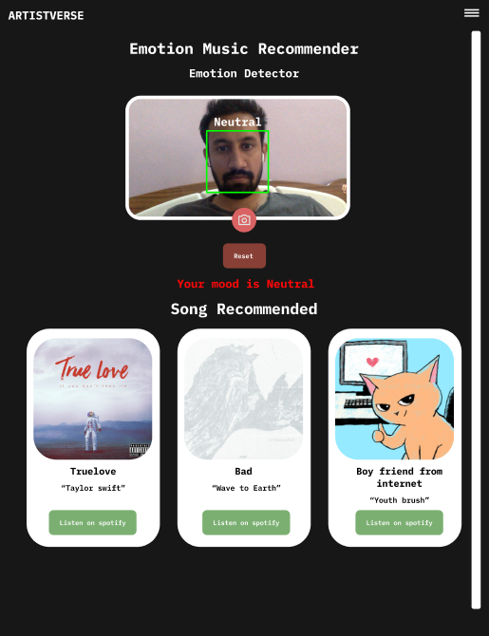
Document  Name | Artistverse-SRS V.3.0 | Owner | NS , WS | Page | 79
Document  Type | Software Requirement  Specification | Release Date | 11/10/2024 | Print date | 11/10/2024

UI-09 Chord Progression page
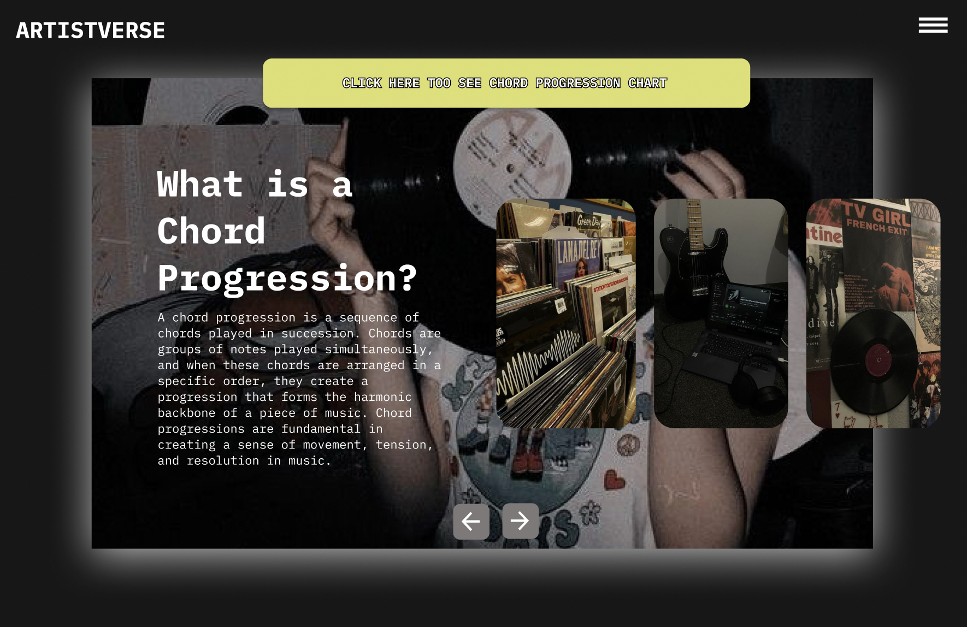
UI-09-1 Chord Progression page when click next button
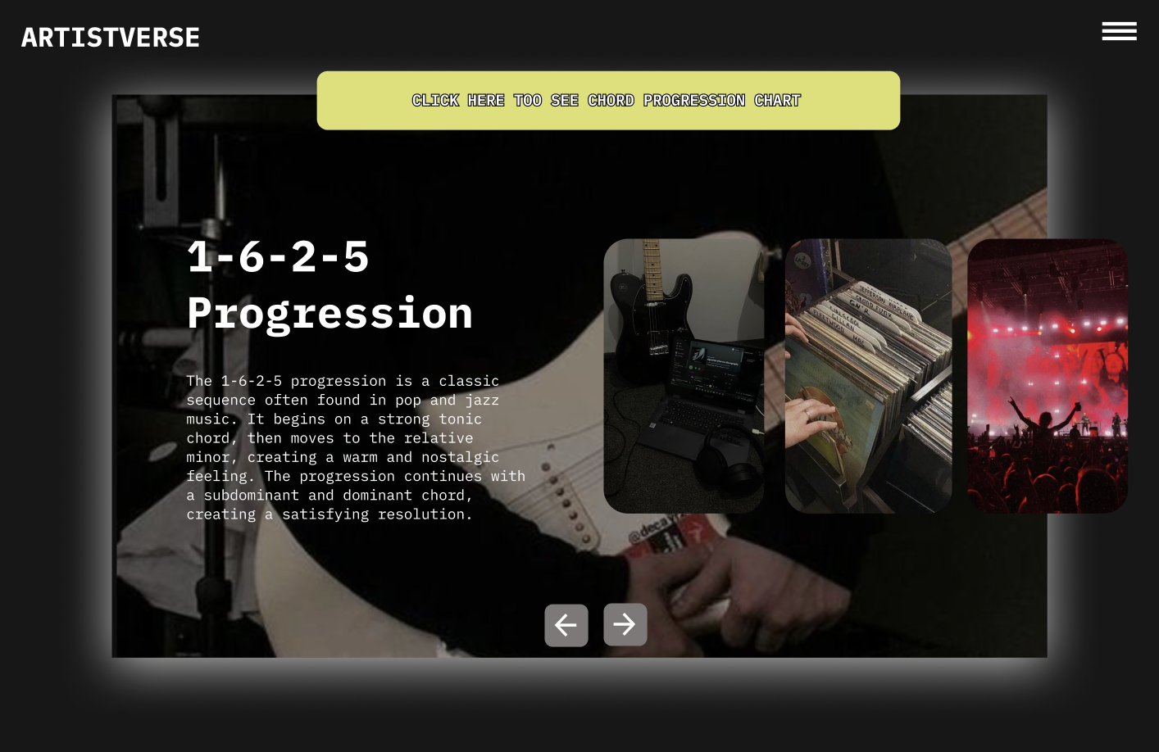
Document  Name | Artistverse-SRS V.3.0 | Owner | NS , WS | Page | 80
Document  Type | Software Requirement  Specification | Release Date | 11/10/2024 | Print date | 11/10/2024

UI-10 Chord Progression Table page
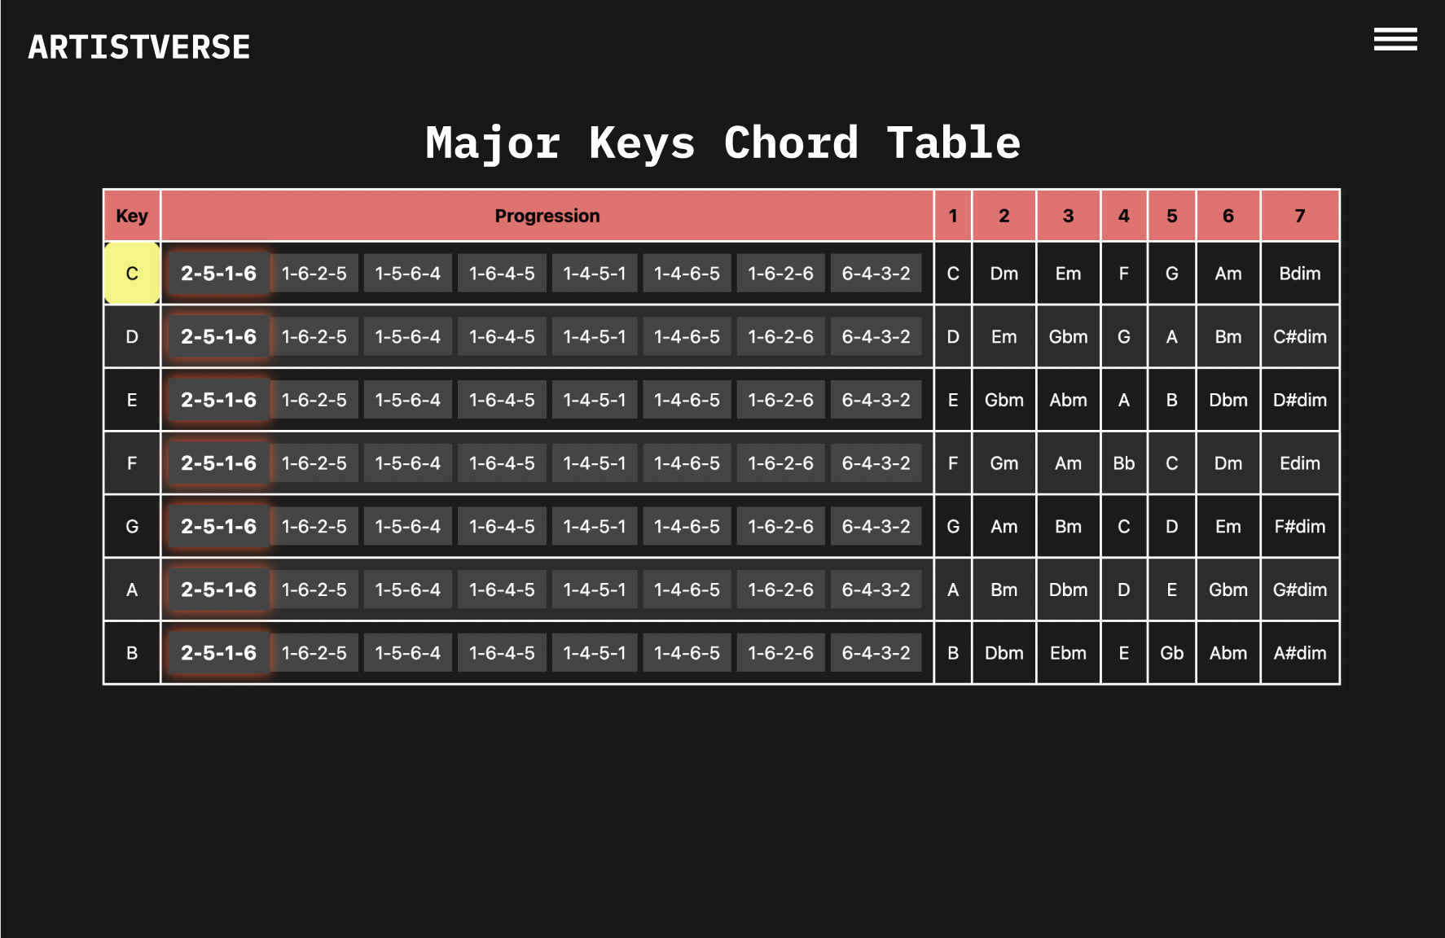
UI-10-1 With selected progression
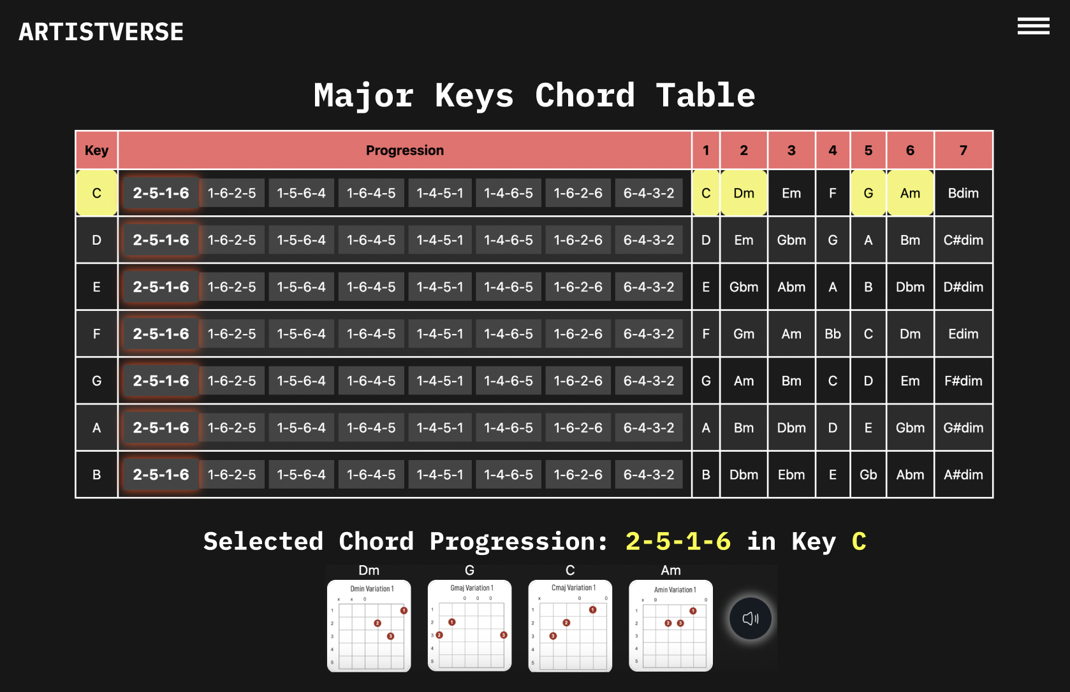
Document  Name | Artistverse-SRS V.3.0 | Owner | NS , WS | Page | 81
Document  Type | Software Requirement  Specification | Release Date | 11/10/2024 | Print date | 11/10/2024

UI-10-2 With highlights the chord in the progression with an orangecolour as the sound it is played.
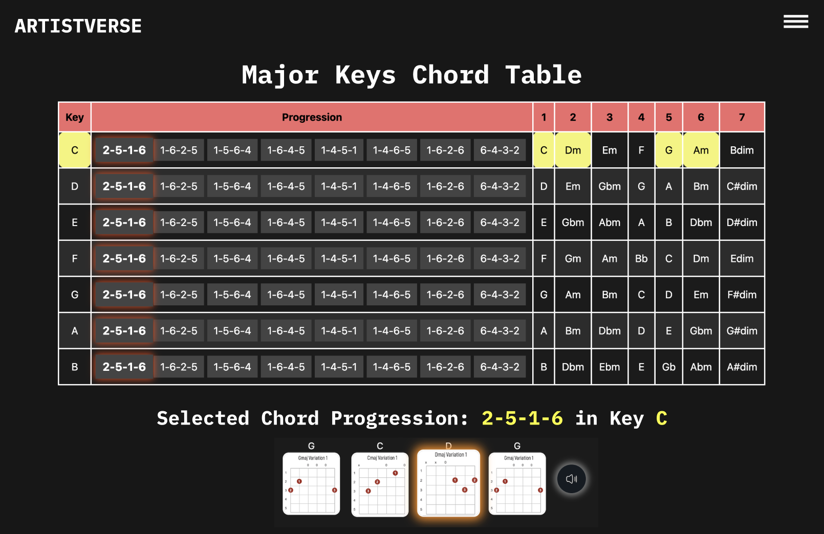
UI-11 AI-Assistance page
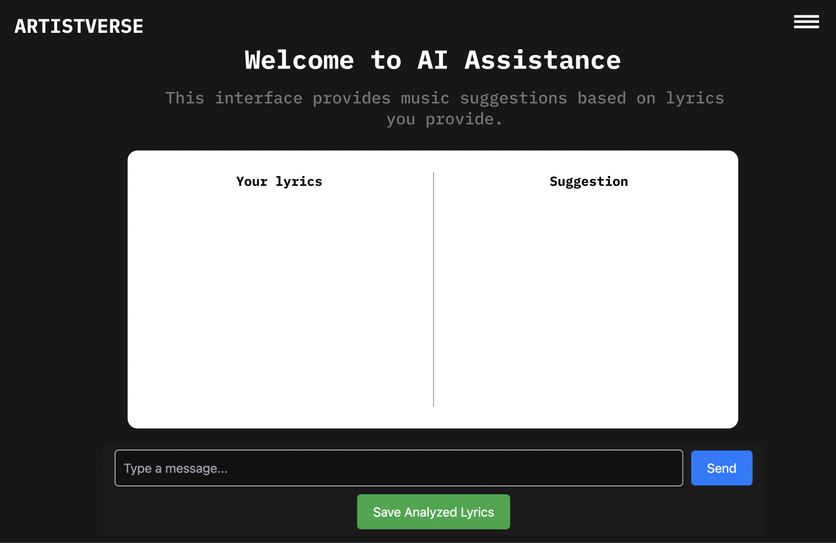
Document  Name | Artistverse-SRS V.3.0 | Owner | NS , WS | Page | 82
Document  Type | Software Requirement  Specification | Release Date | 11/10/2024 | Print date | 11/10/2024

UI-11-1 With invalid input
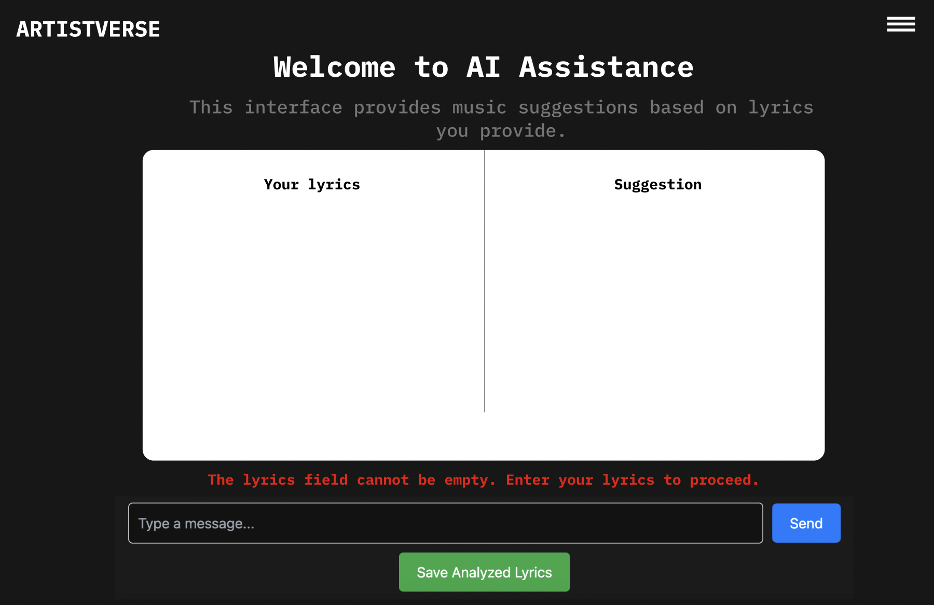
UI-11-2 With User input
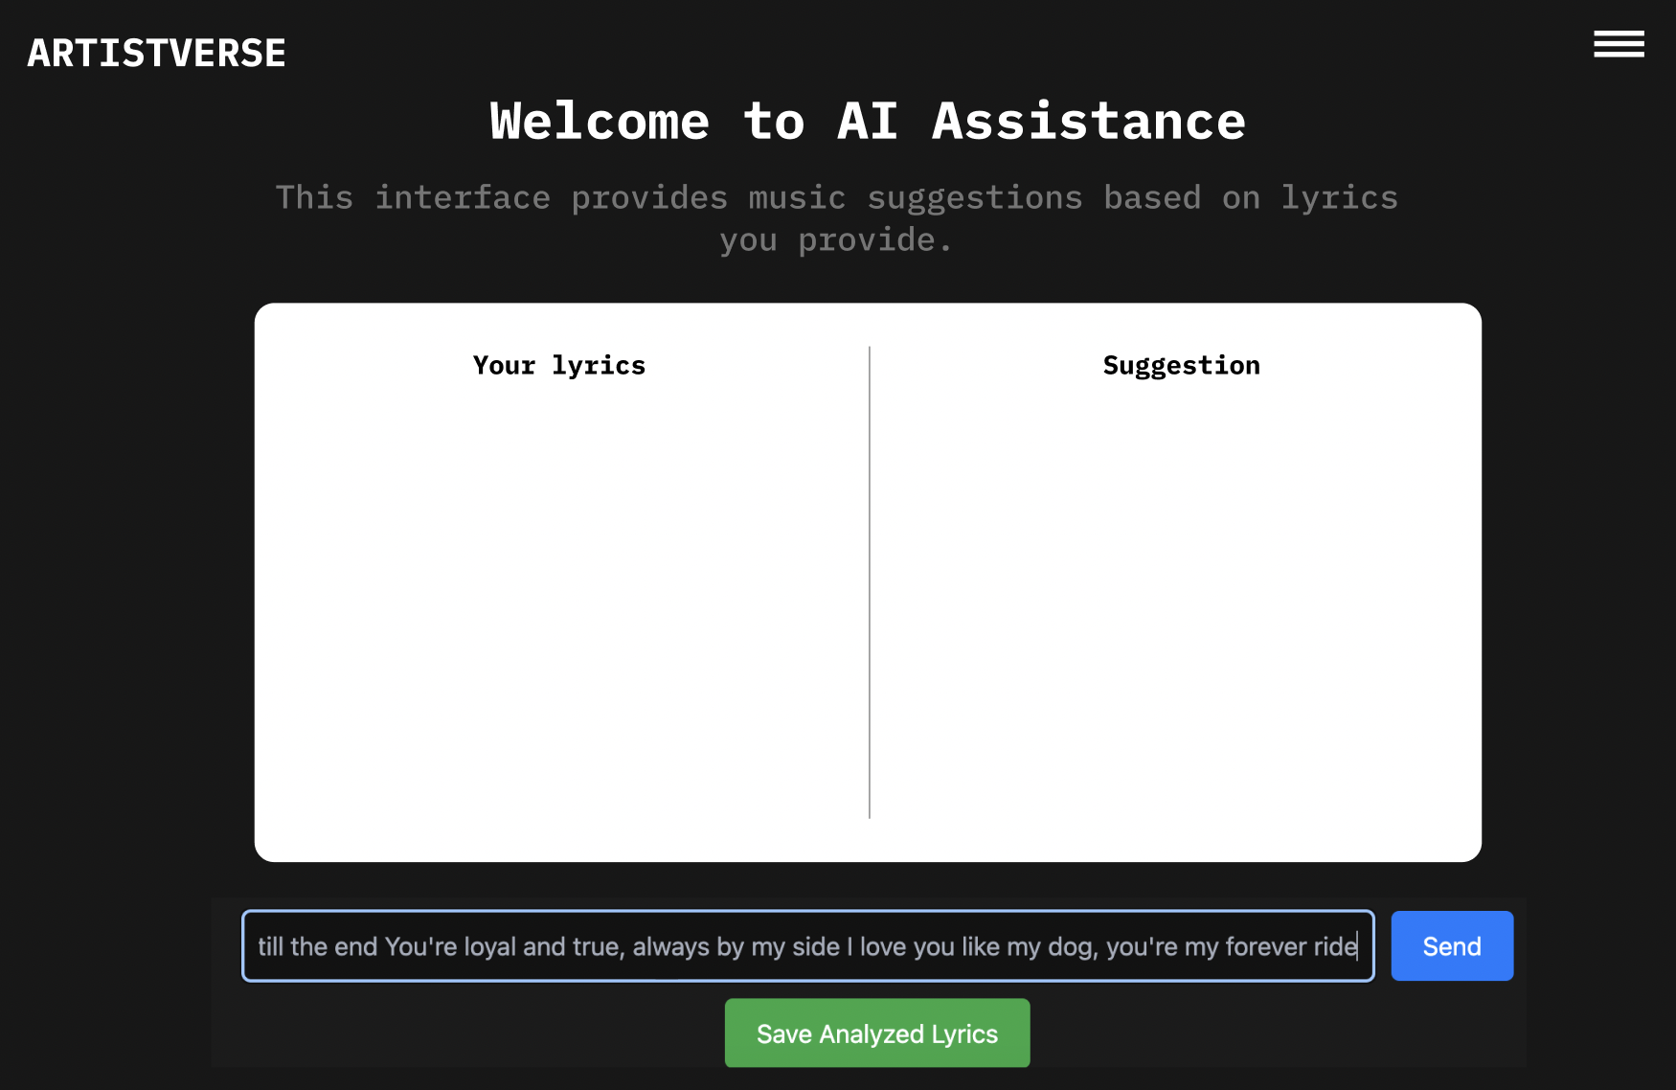
Document  Name | Artistverse-SRS V.3.0 | Owner | NS , WS | Page | 83
Document  Type | Software Requirement  Specification | Release Date | 11/10/2024 | Print date | 11/10/2024

UI-11-3 Proceed without internet connection
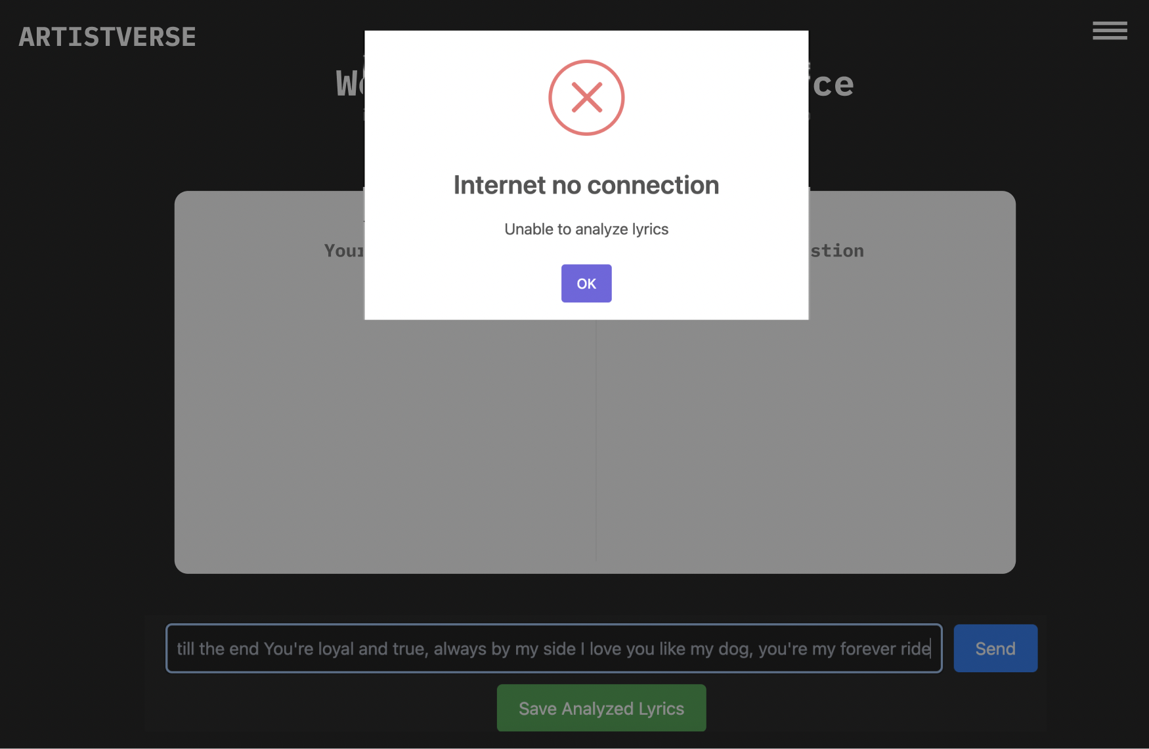
UI-11-4 With input after click button “Send”
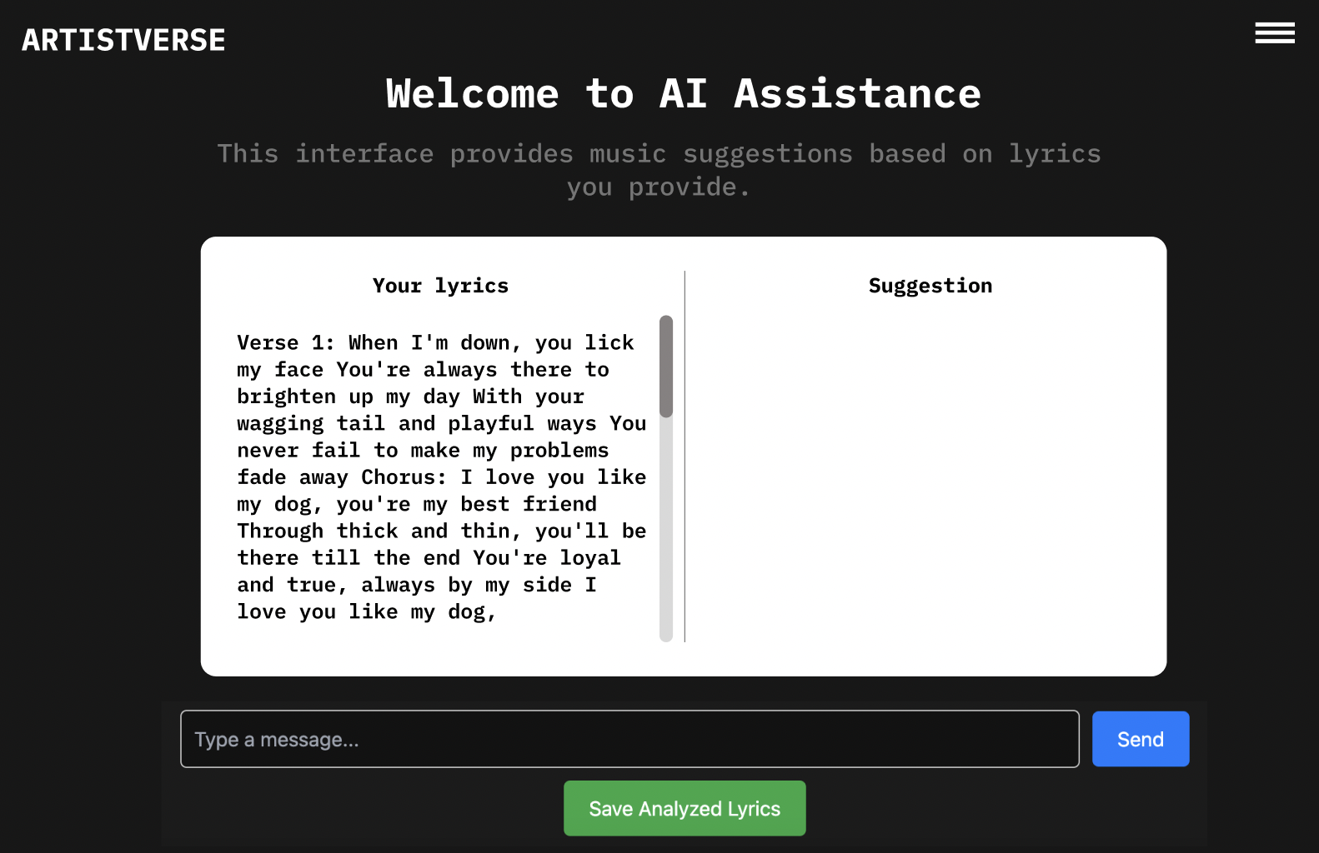
Document  Name | Artistverse-SRS V.3.0 | Owner | NS , WS | Page | 84
Document  Type | Software Requirement  Specification | Release Date | 11/10/2024 | Print date | 11/10/2024

UI-11-5 With suggestion analyzed
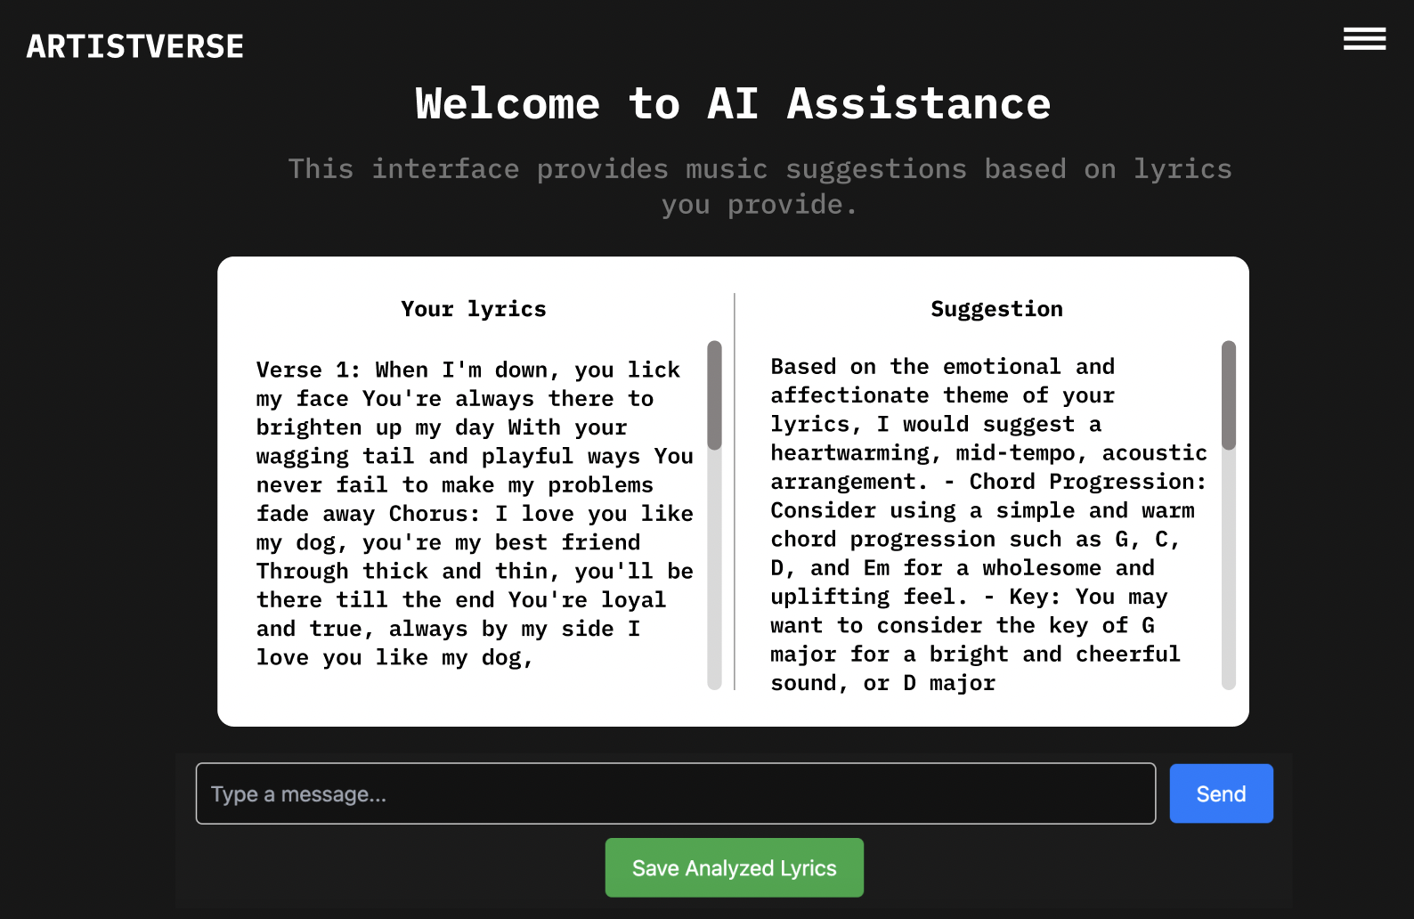
UI-11-6 With User click save analyzed lyrics
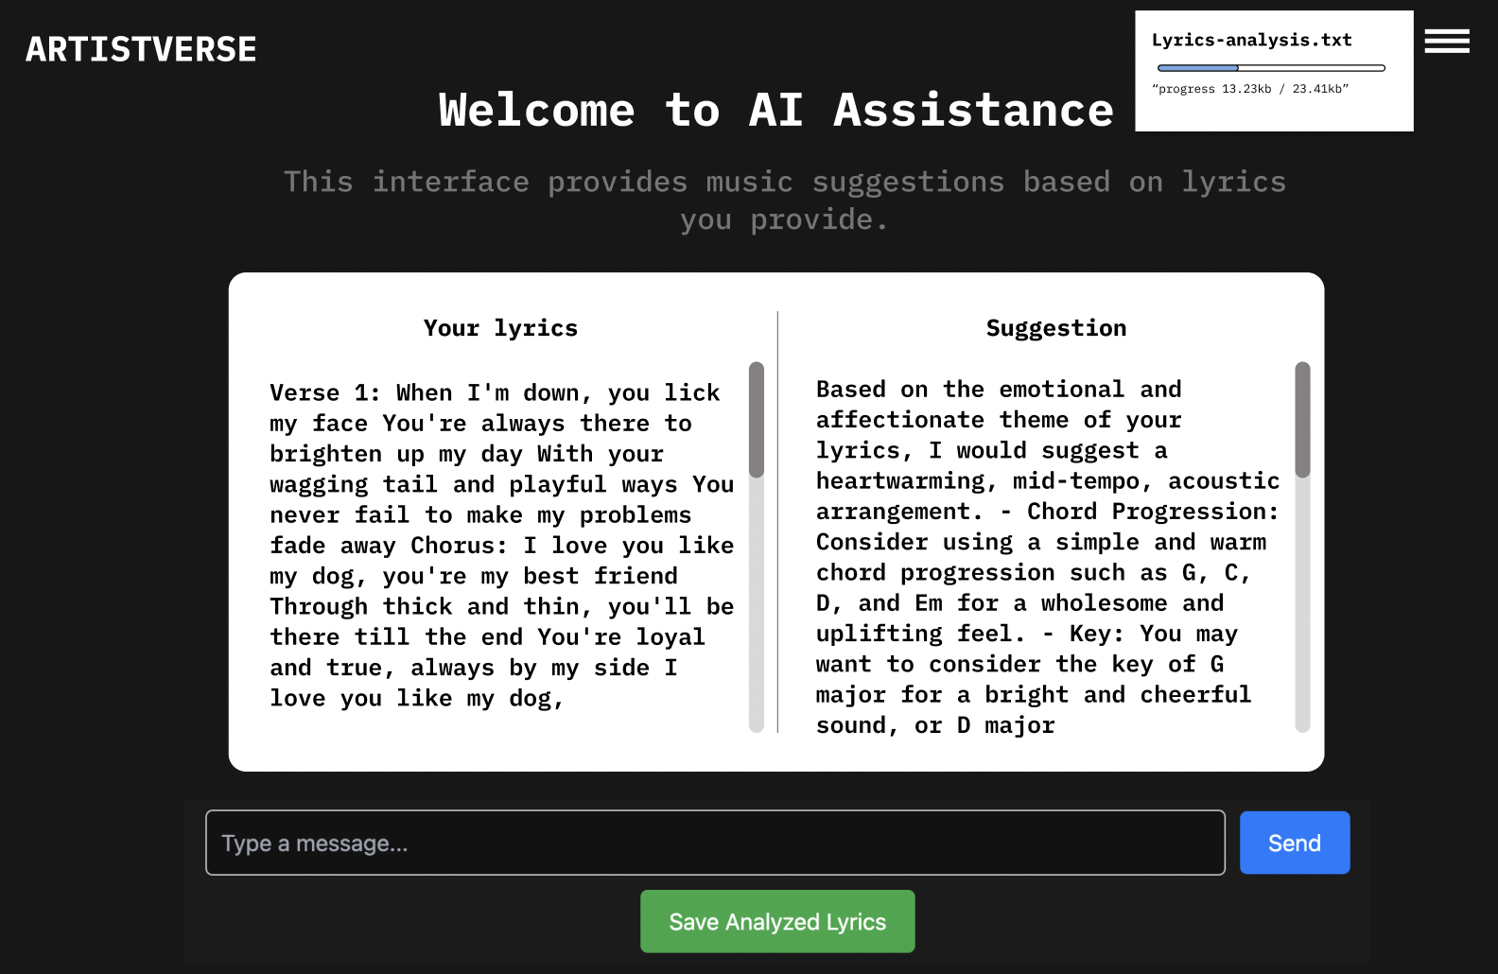
Document  Name | Artistverse-SRS V.3.0 | Owner | NS , WS | Page | 85
Document  Type | Software Requirement  Specification | Release Date | 11/10/2024 | Print date | 11/10/2024

UI-11-7 With no internet connection when clicking “Save AnalyzedLyrics”
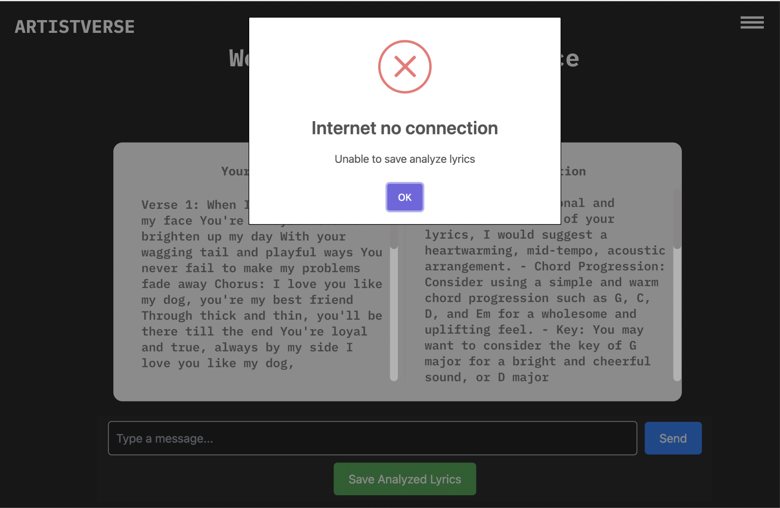
Document  Name | Artistverse-SRS V.3.0 | Owner | NS , WS | Page | 86
Document  Type | Software Requirement  Specification | Release Date | 11/10/2024 | Print date | 11/10/2024

Document  Name | Artistverse-SRS V.3.0 | Owner | NS , WS | Page | 87
Document  Type | Software Requirement  Specification | Release Date | 11/10/2024 | Print date | 11/10/2024

